**Transaction**

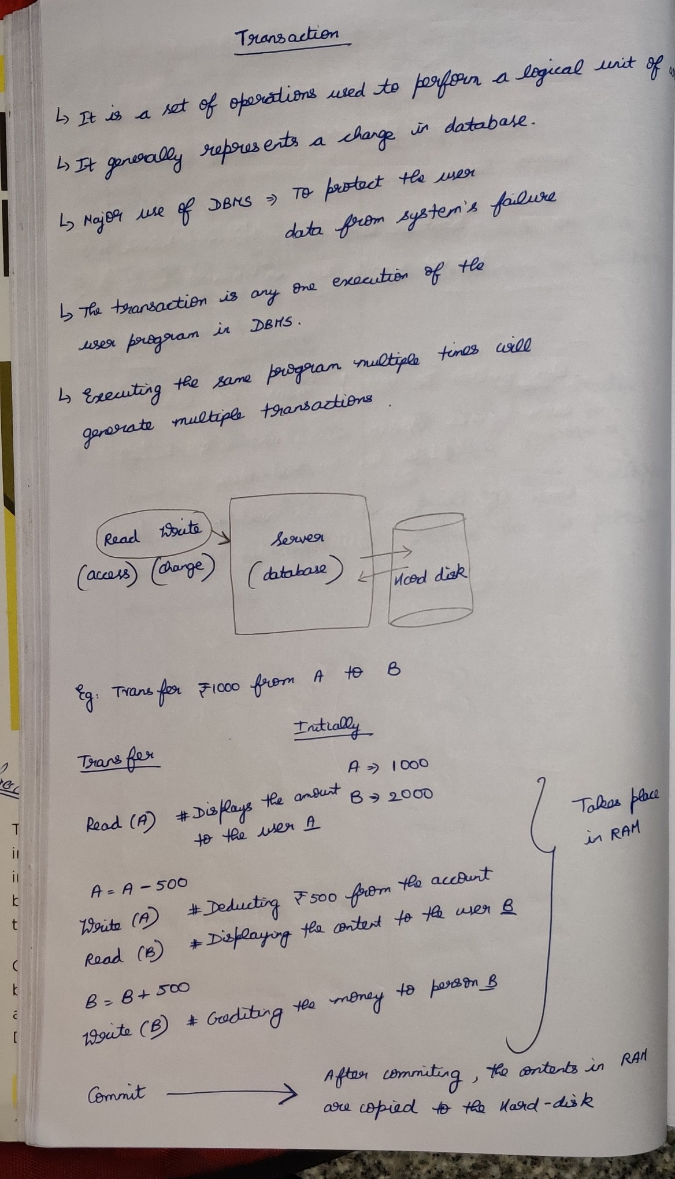

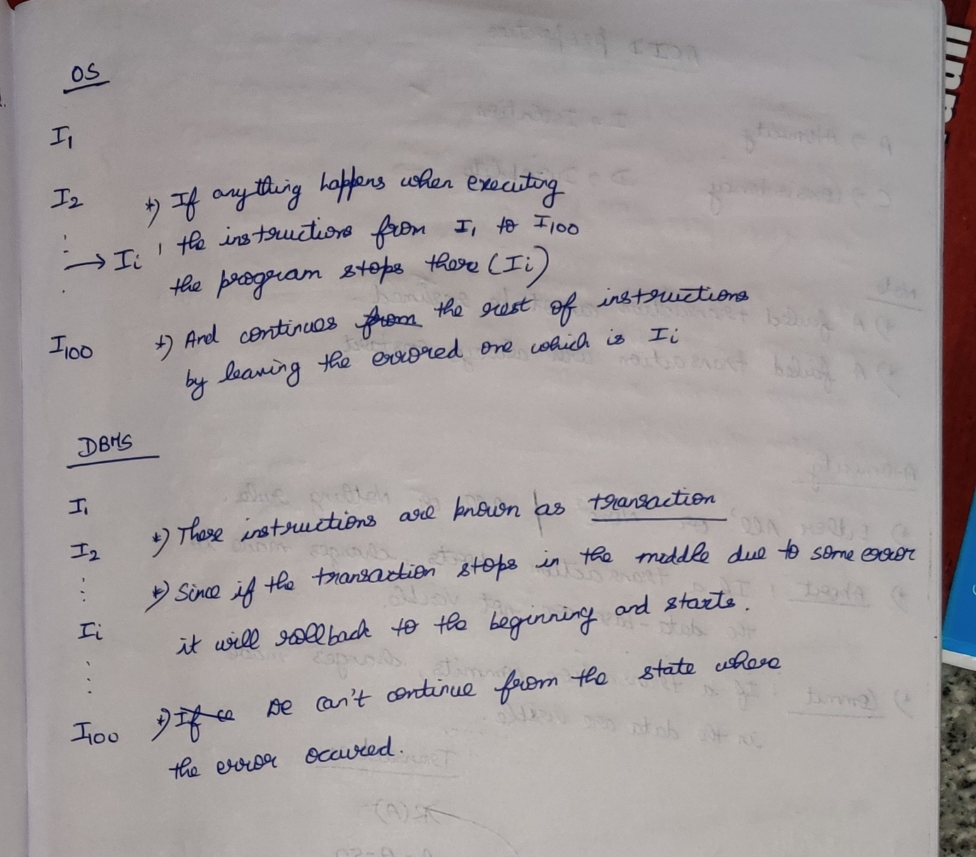

**ACID Properties**

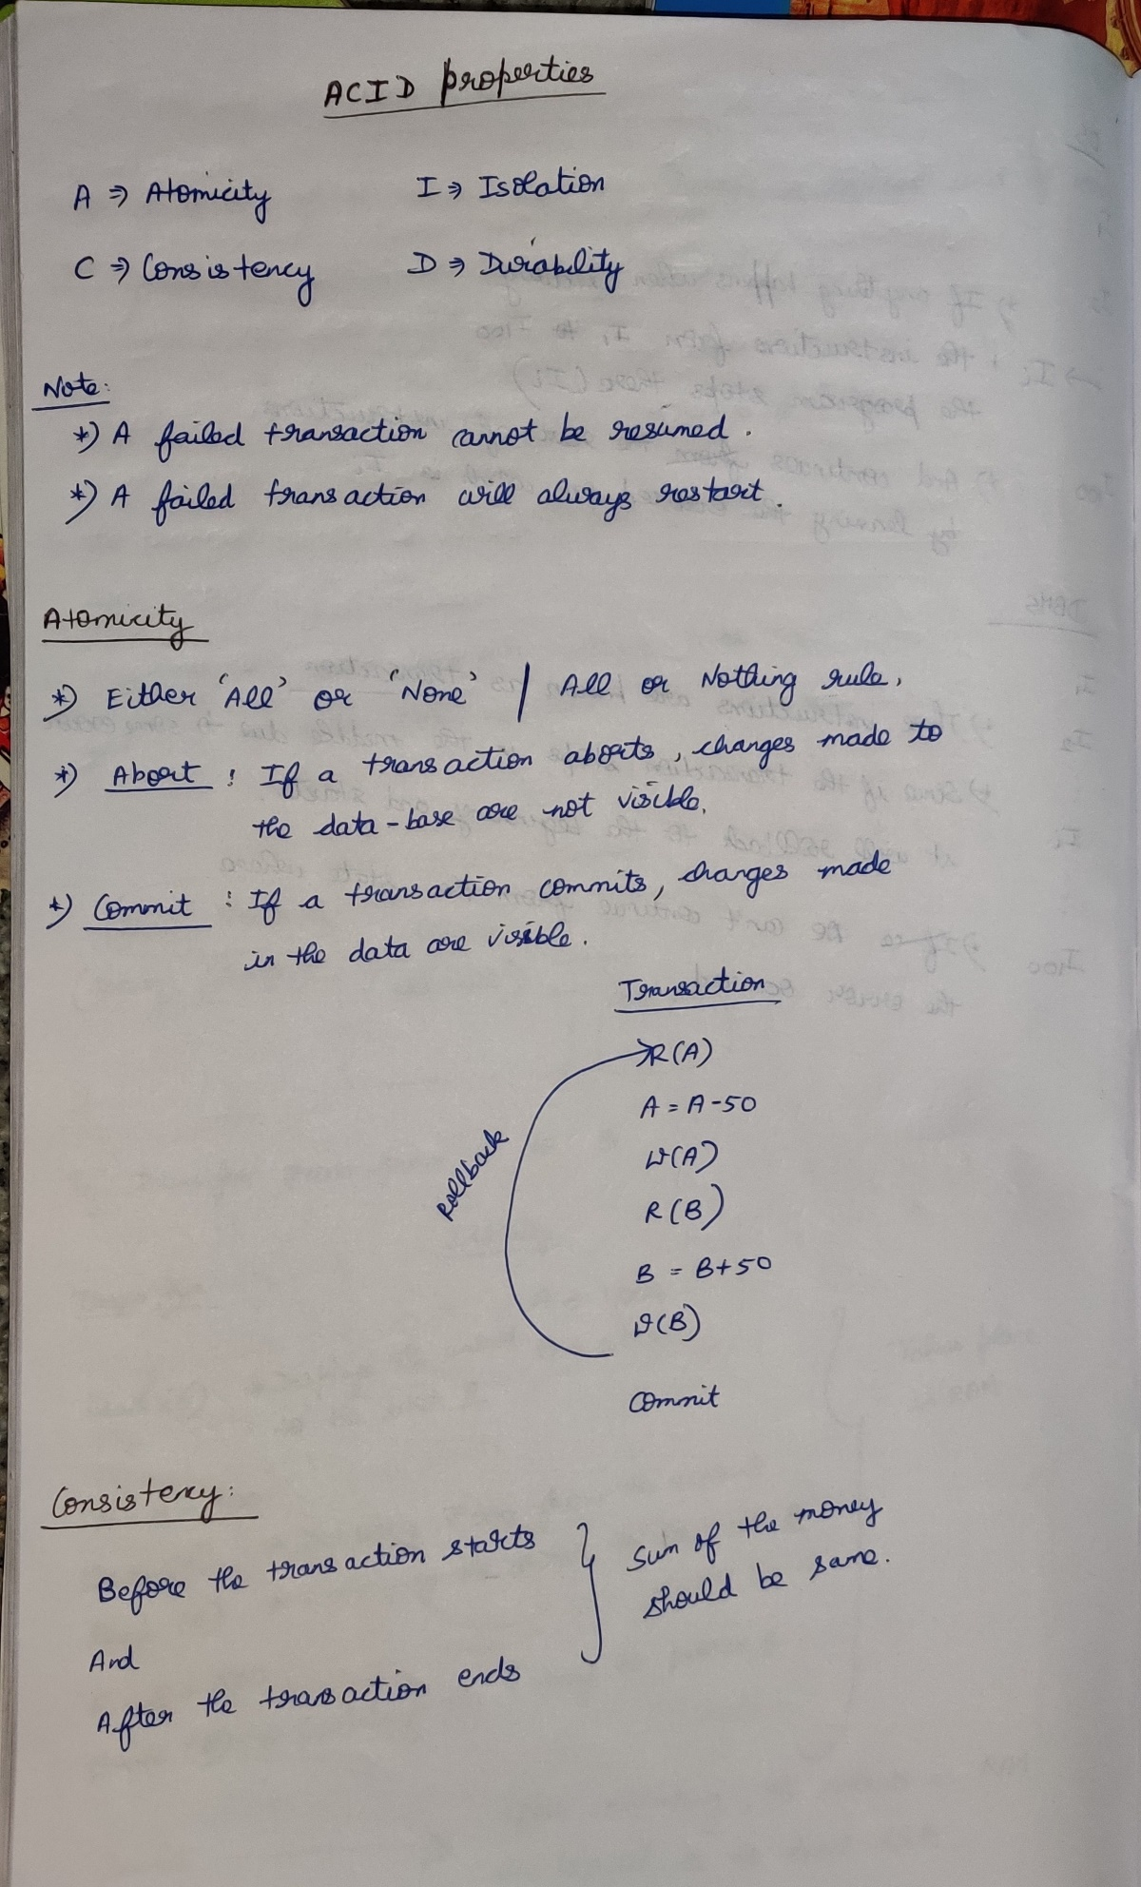

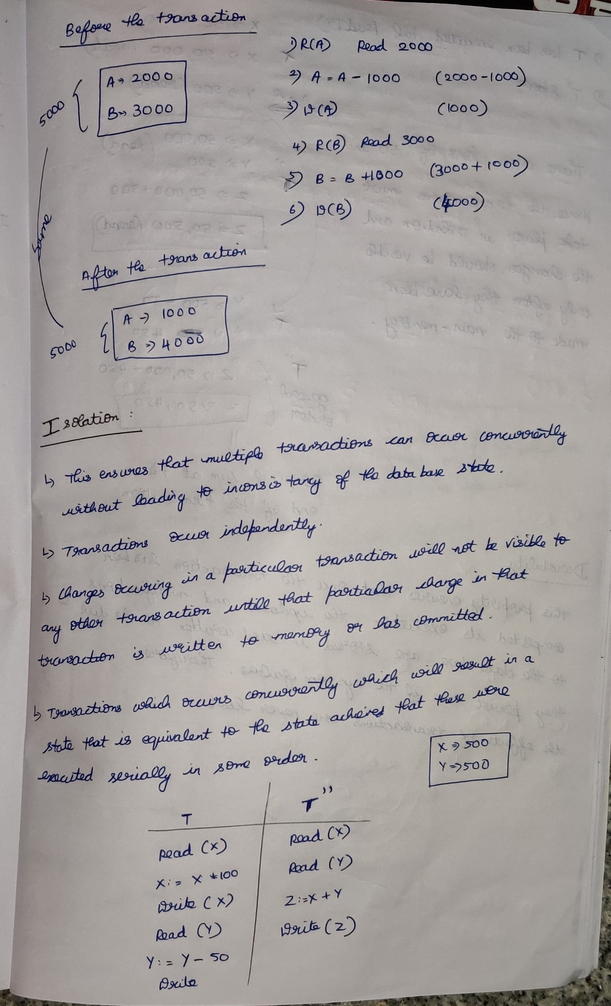

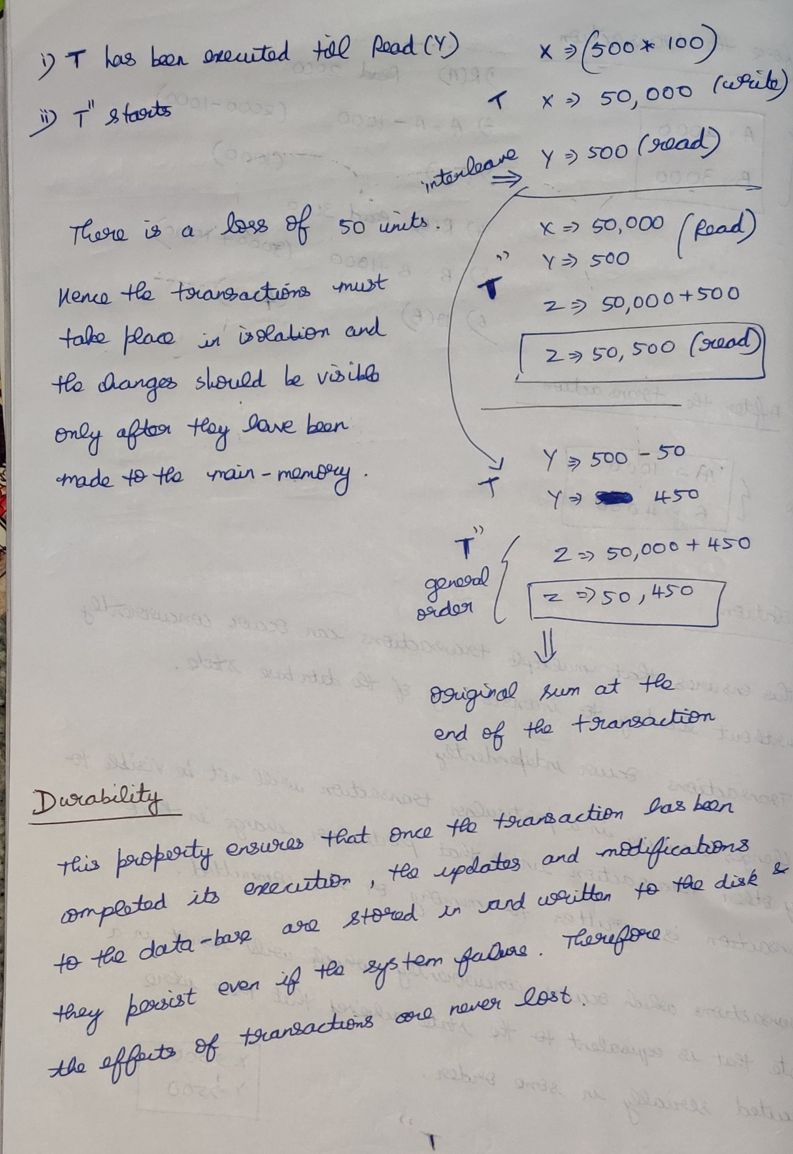

**Transaction Recovery**

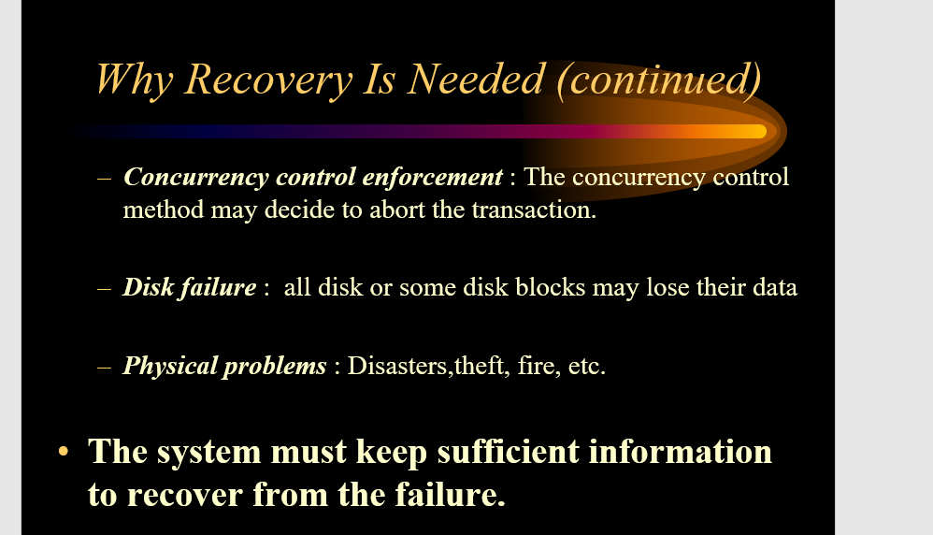  
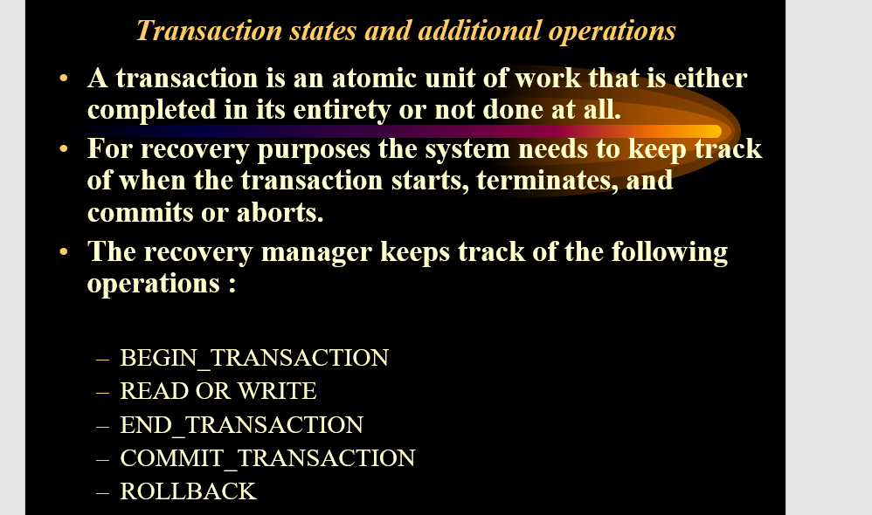

**Transaction states in DBMS**

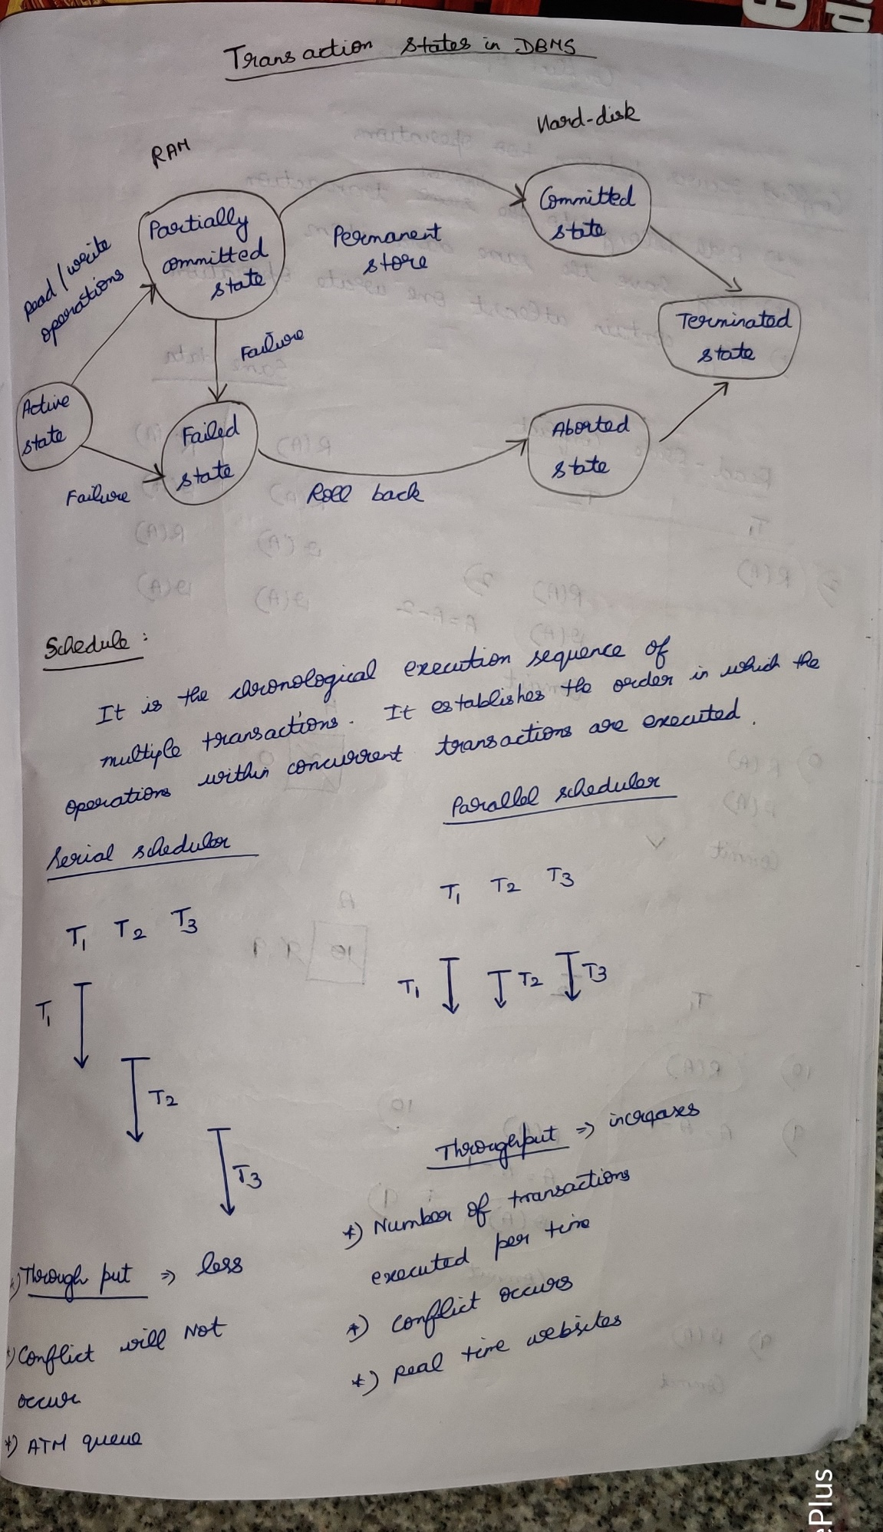

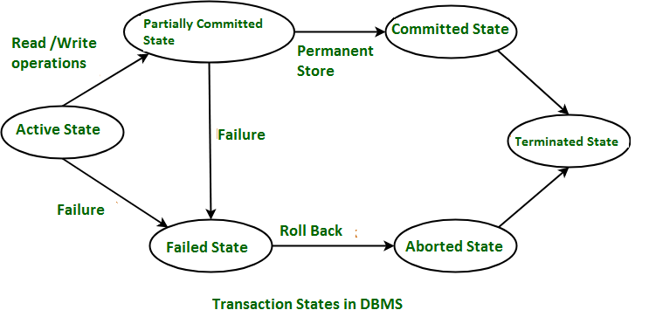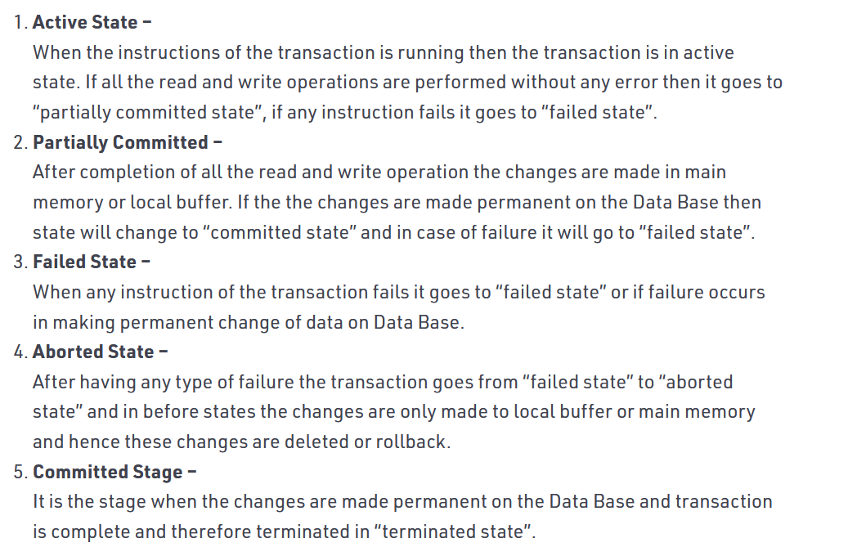  
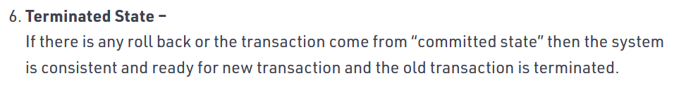Aborted state 🡪 After the **transaction** has failed and entered into a failed **state**, all the changes made by it have to be undone. To undo the changes made by the **transaction**, it becomes necessary to roll back the **transaction**. After the **transaction** has rolled back completely, it enters into an **aborted state**.

**The System Logs**

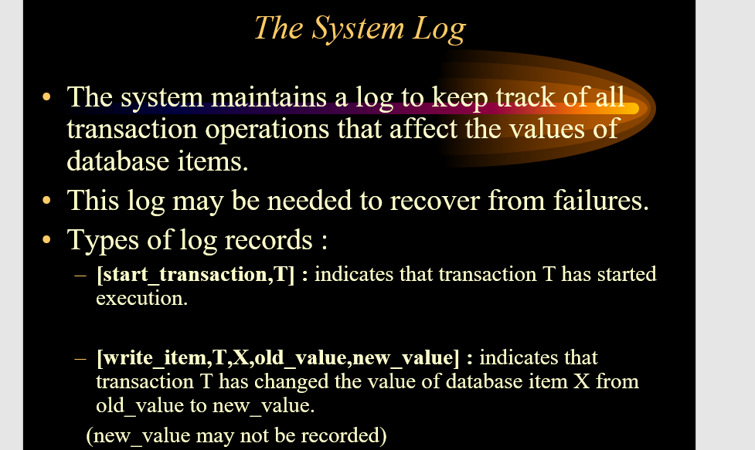  
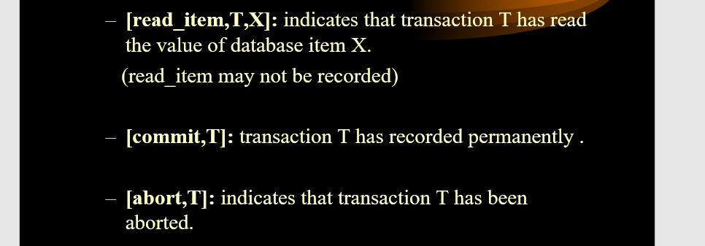

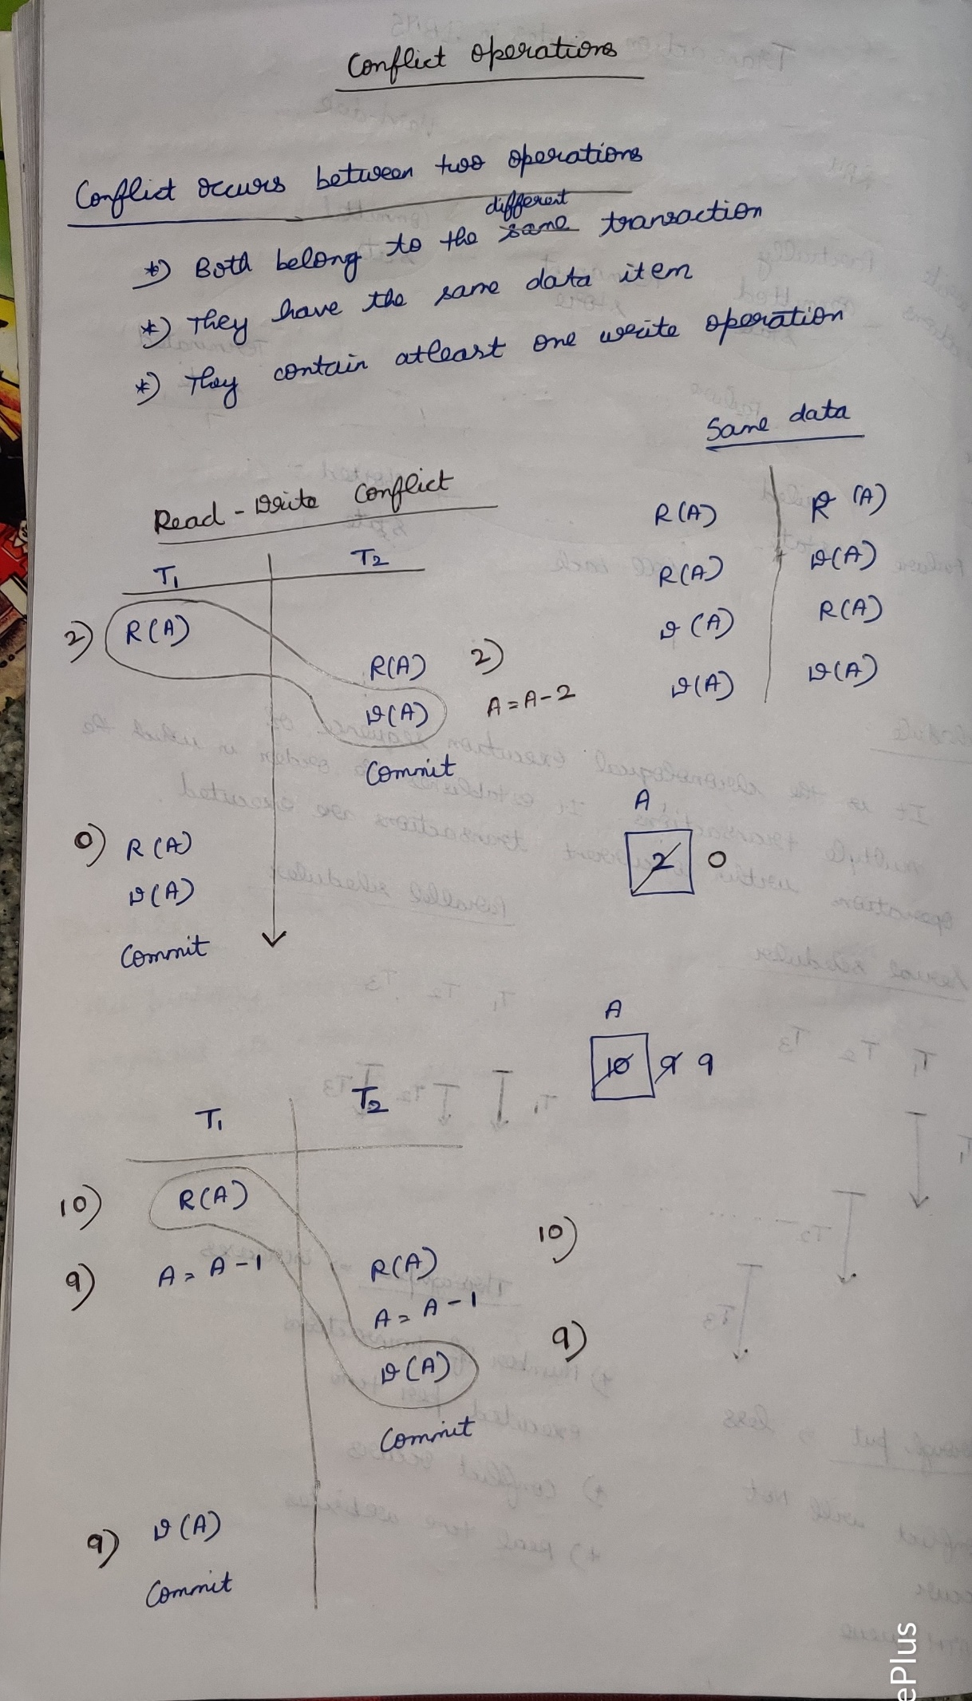

**Schedules of Transaction**

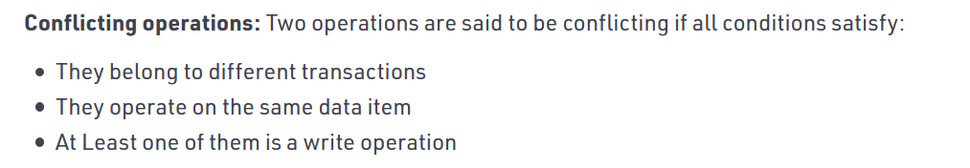

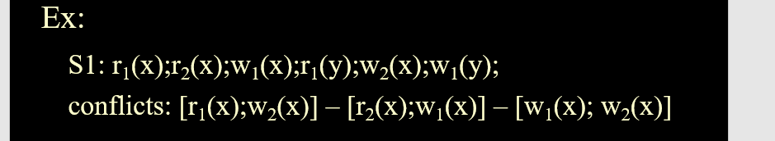

This is a conflict since two operations occurs on the same data-item

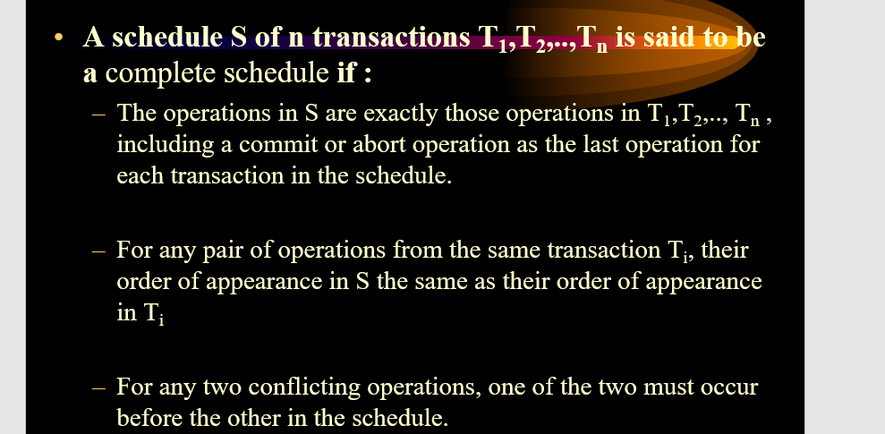

**Concurrency**

Possible problems due to concurrency   
1) Lost Update Problem / write-write conflict  
2) Temporal Update / Dirty read problem   
3) Incorrect Summary Problem

**Lost Update Problem/Write-write conflict**

The problem occurs when two different database transactions perform the read/write operations on the same database items in an interleaved manner (i.e., concurrent execution) that makes the values of the items incorrect hence making the database inconsistent.

**For example:**

**Consider the below diagram where two transactions TX and TY, are performed on the same account A where the balance of account A is $300.**

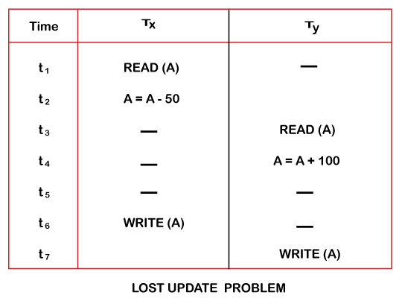



* At time t1, transaction TX reads the value of account A, i.e., $300 (only read).
* At time t2, transaction TX deducts $50 from account A that becomes $250 (only deducted and not updated/write).
* Alternately, at time t3, transaction TY reads the value of account A that will be $300 only because TX didn't update the value yet.
* At time t4, transaction TY adds $100 to account A that becomes $400 (only added but not updated/write).
* At time t6, transaction TX writes the value of account A that will be updated as $250 only, as TY didn't update the value yet.
* Similarly, at time t7, transaction TY writes the values of account A, so it will write as done at time t4 that will be $400. It means the value written by TX is lost, i.e., $250 is lost.

Hence data becomes incorrect, and database sets to inconsistent.

Eg-2  
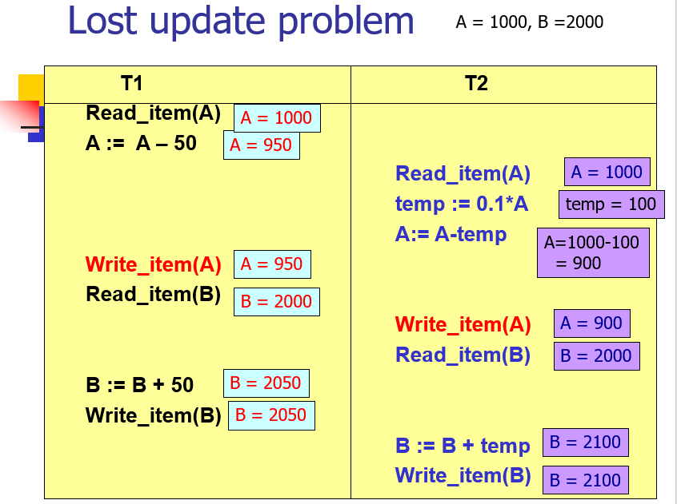

**Temporal Update / Dirty Read Problem(Write-read conflict)**

The dirty read problem occurs *when one transaction updates an item of the database, and somehow the transaction fails, and before the data gets rollback, the updated database item is accessed by another transaction. There comes the Read-Write Conflict between both transactions.*

**For example:**

**Consider two transactions TX and TY in the below diagram performing read/write operations on account A where the available balance in account A is $300:**

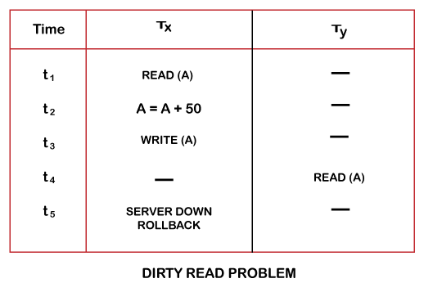



* At time t1, transaction TX reads the value of account A, i.e., $300.
* At time t2, transaction TX adds $50 to account A that becomes $350.
* At time t3, transaction TX writes the updated value in account A, i.e., $350.
* Then at time t4, transaction TY reads account A that will be read as $350.
* Then at time t5, transaction TX rollbacks due to server problem, and the value changes back to $300 (as initially).
* But the value for account A remains $350 for transaction TY as committed, which is the dirty read and therefore known as the Dirty Read Problem.

**Incorrect Summary Problem**

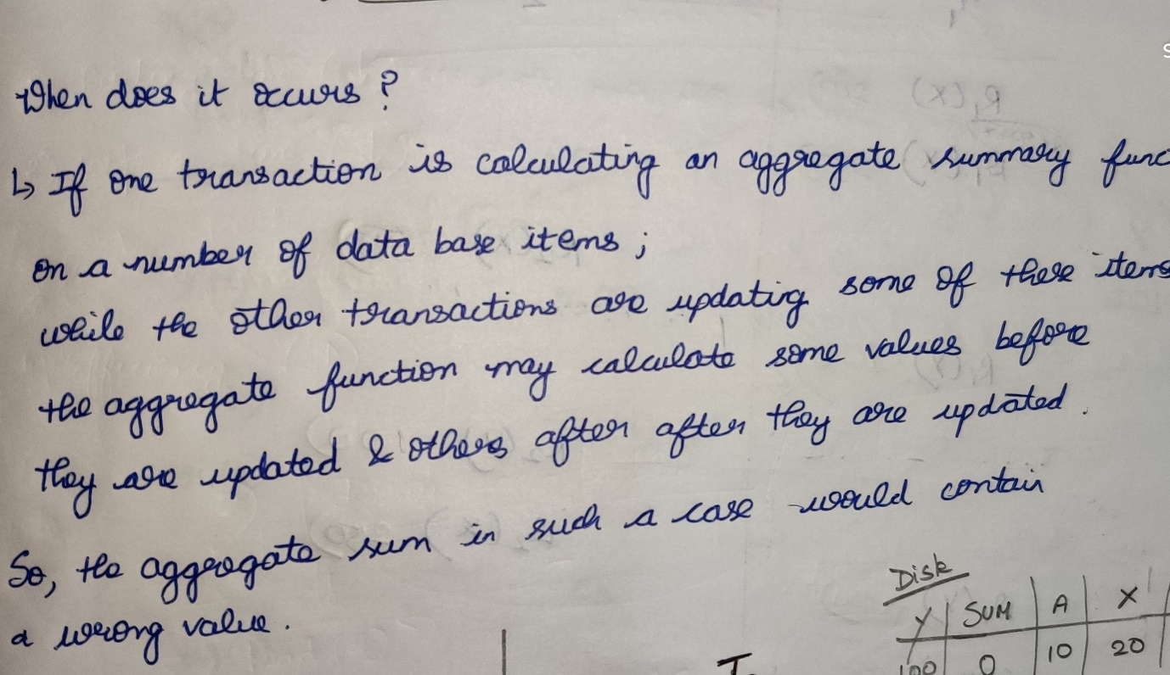

Actual sum is 300, but we are getting the sum as 400

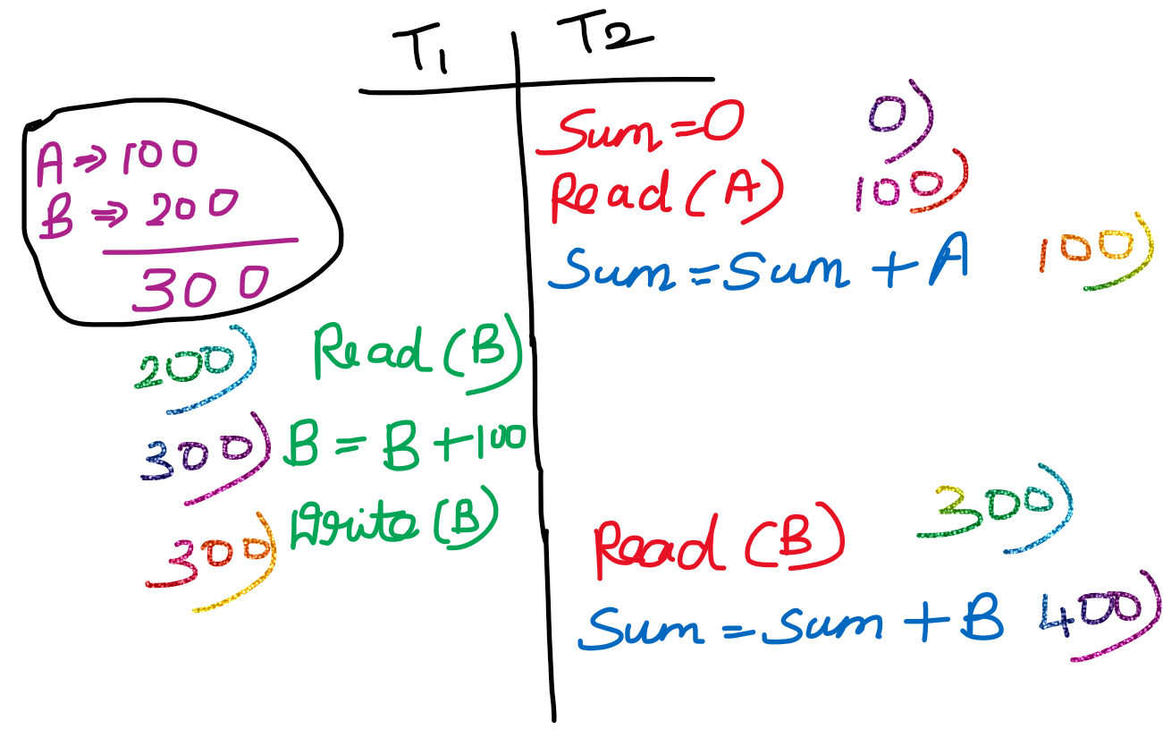

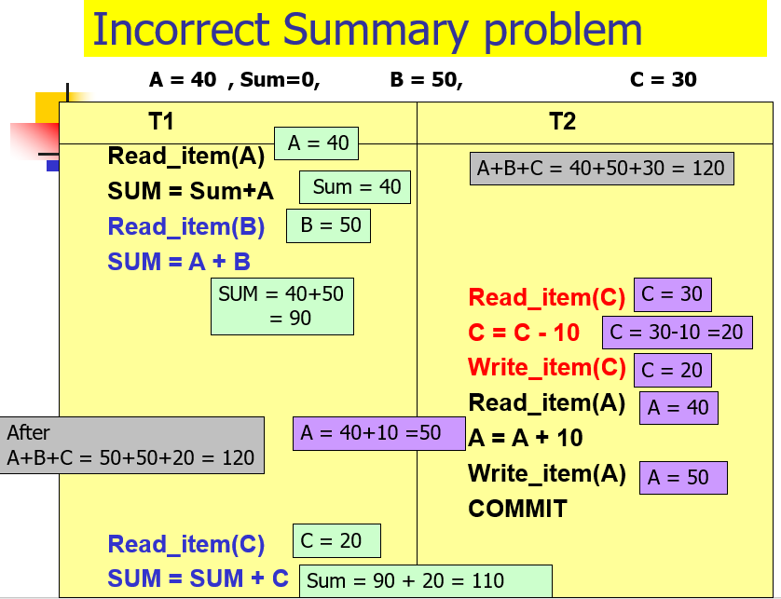

Actual sum (A+B+C 🡪 40+50+30=120)  
But at-last we are getting the sum as 110 which is wrong.

**Types of Scheduler**

1. **Recoverability 2) Serializability**

**Recoverability**

1. Recoverable Scheduler and Ir-recoverable Scheduler
2. Cascading Abort and Cascade-less Schedule
3. Strict schedule

**Recoverability**

**Recoverable Schedules**

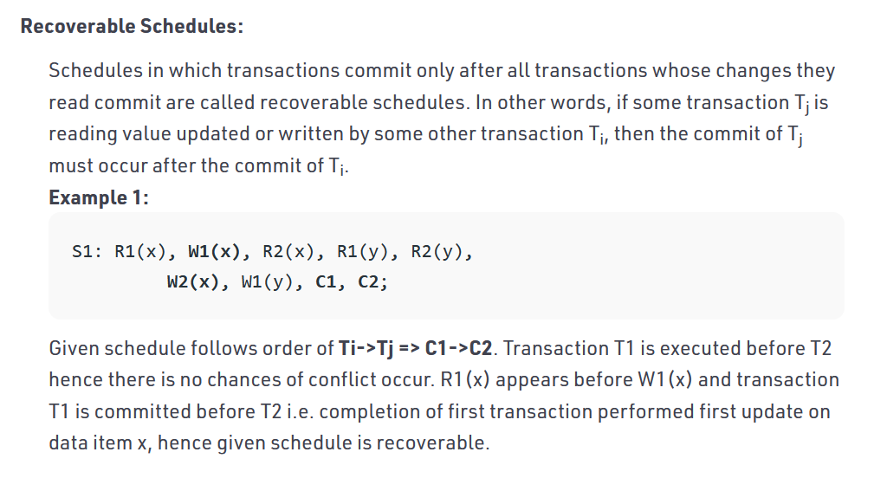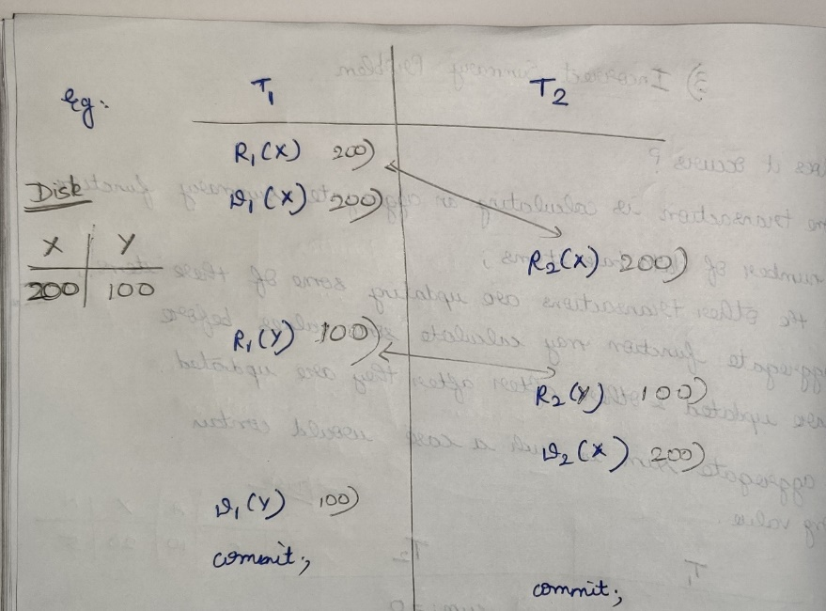

**Ir-recoverable Schedules**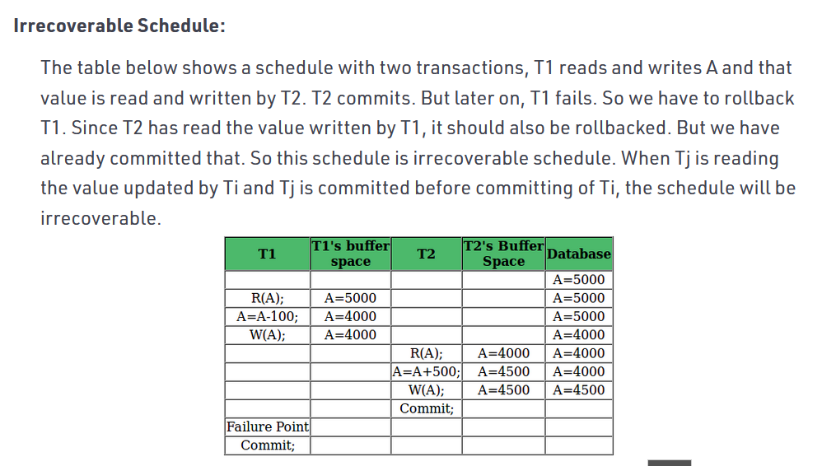

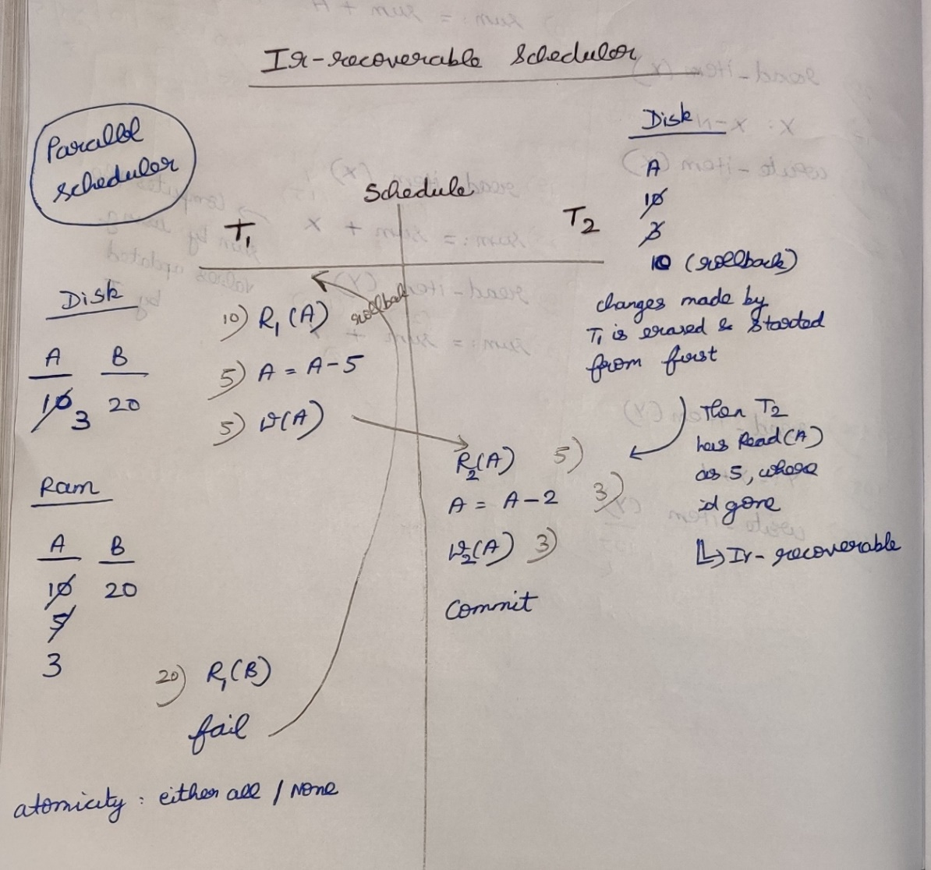

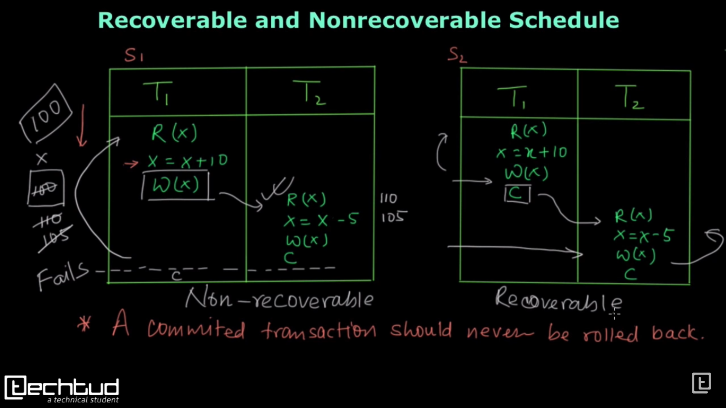

**Non-Recoverable:**  
If any failure happens in T1, then it will rollback so X’s value 🡪 100, but in T2 Read(X) 🡪 110 which lead to data-inconsistent.

**Recoverable:**If any failure happens in T1, then it will roll-back until that T2 will not start its operation.  
If any failure happens in T2, then it will roll-back to T2 itself so there is no effect in T1.

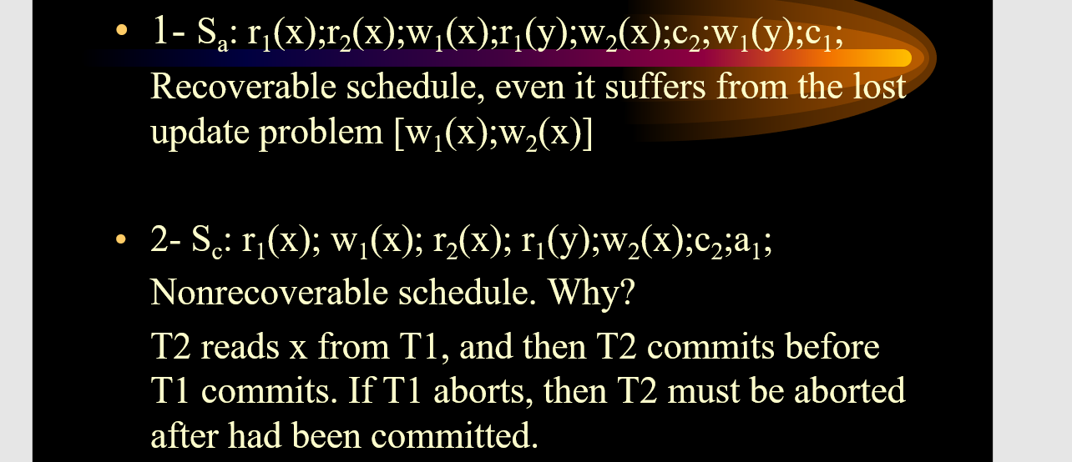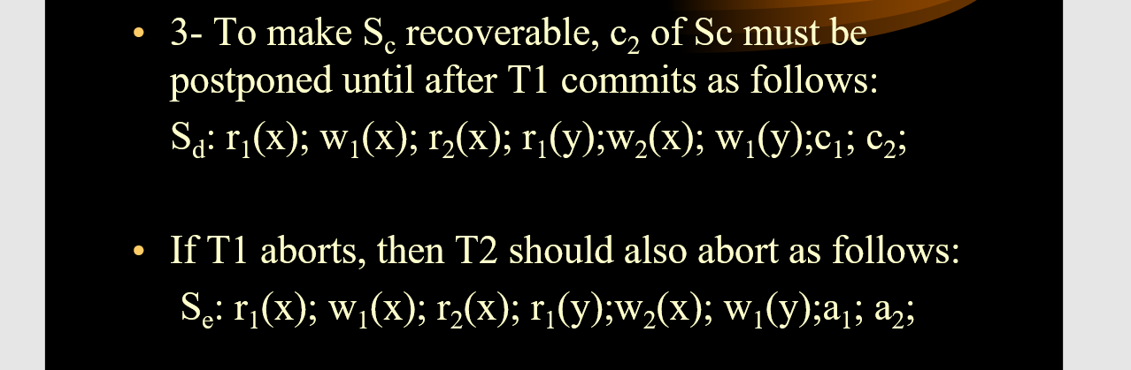

**Cascading Abort Schedule / Cascading Schedule**

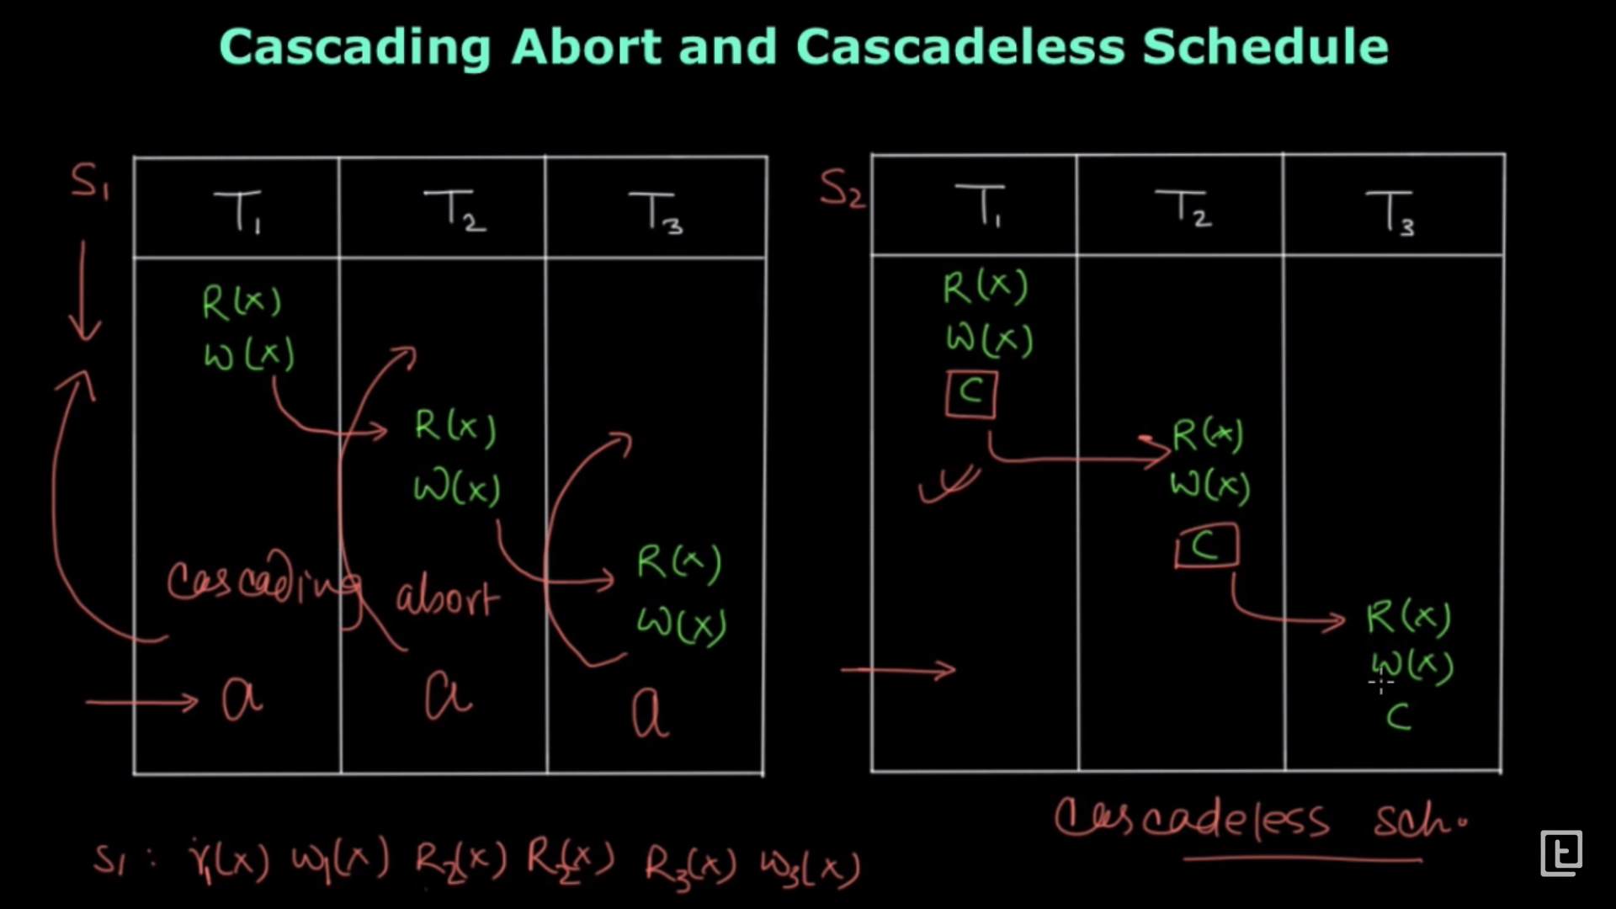

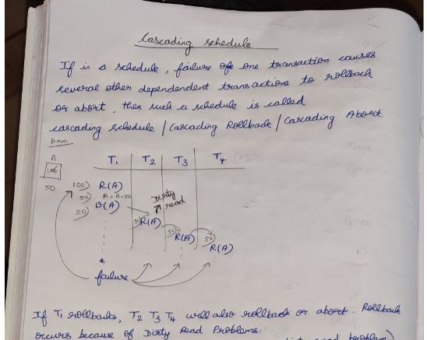

**Cascade less Schedules *(Read is allowed only after committing)***

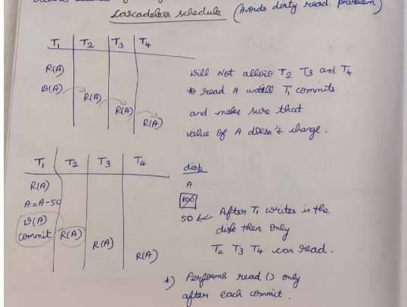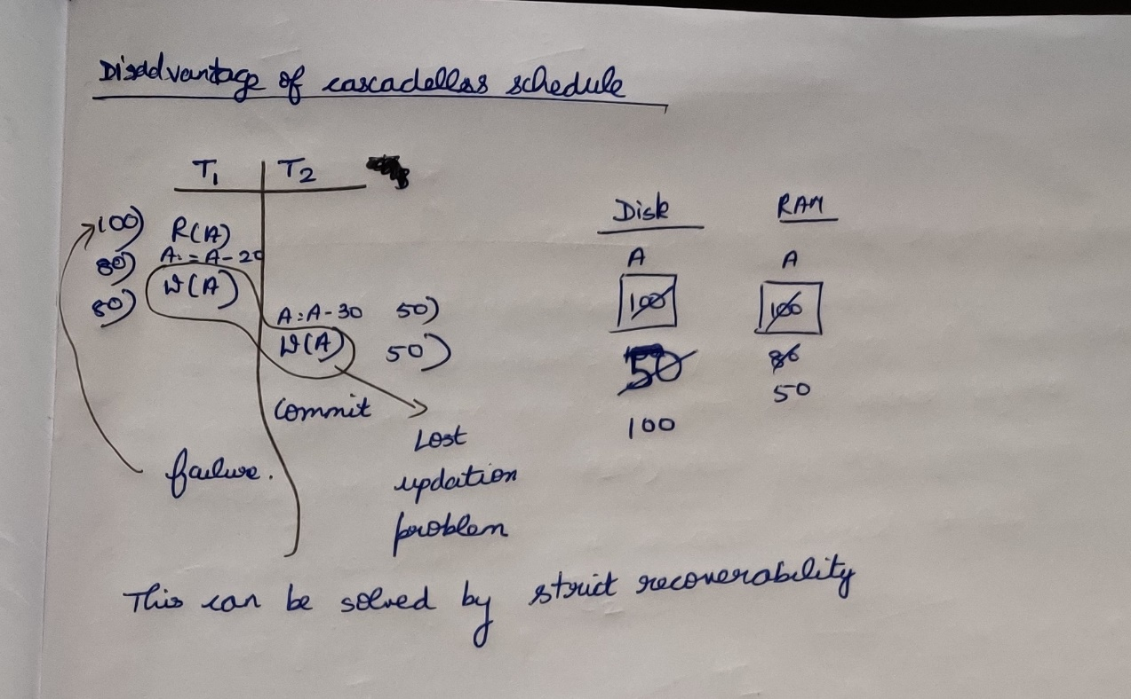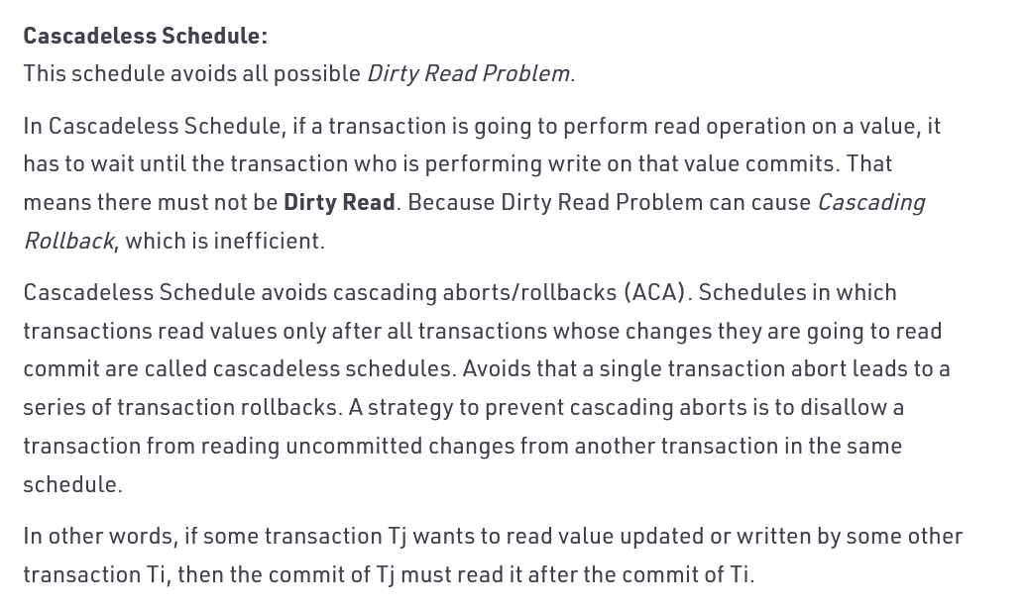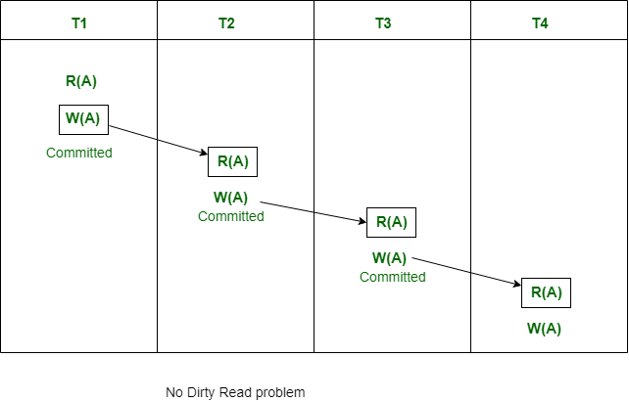

**Strict Schedule**

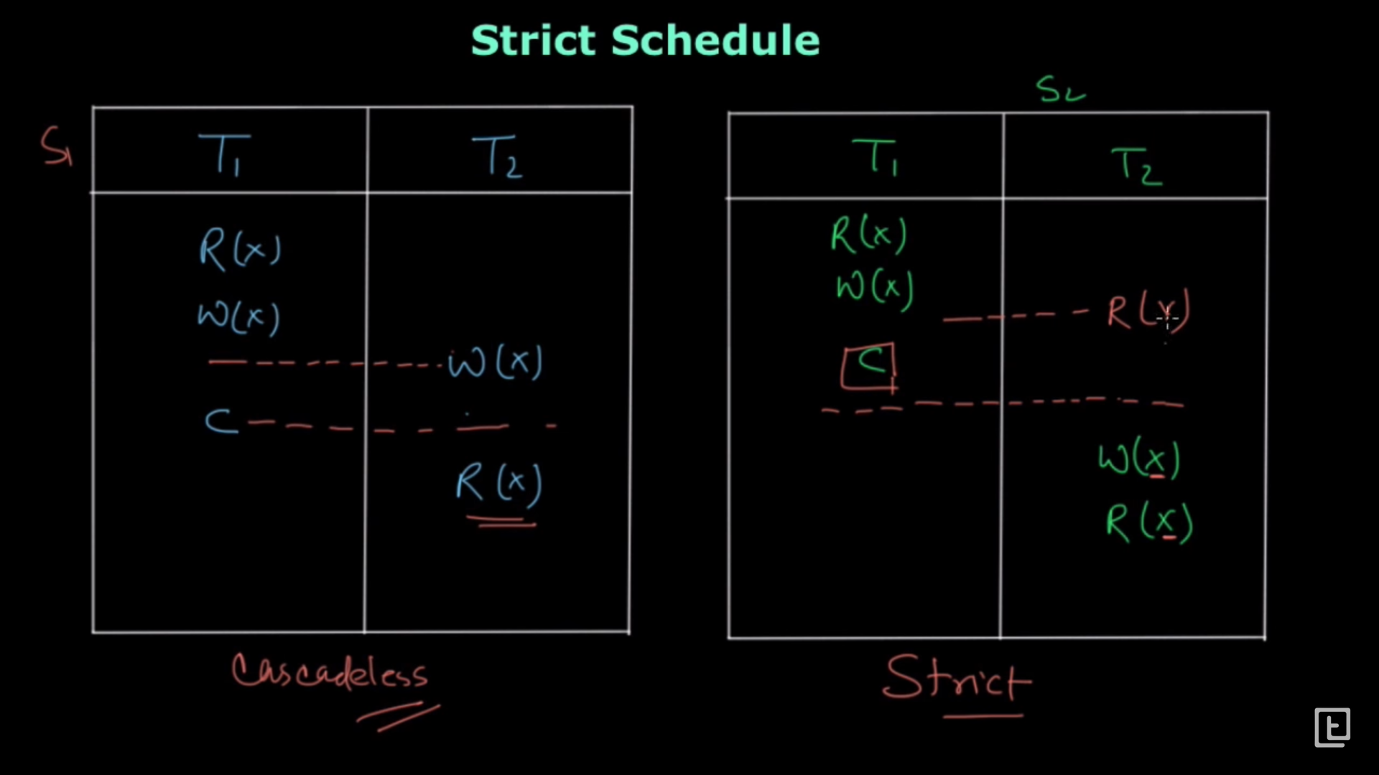

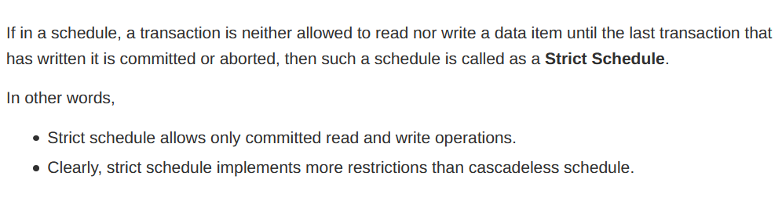

Single data-item (X) 🡪 strict schedule can also become serial scheduler  
Multiple data-item (X,Y,…) 🡪 strict schedule is not serial scheduler

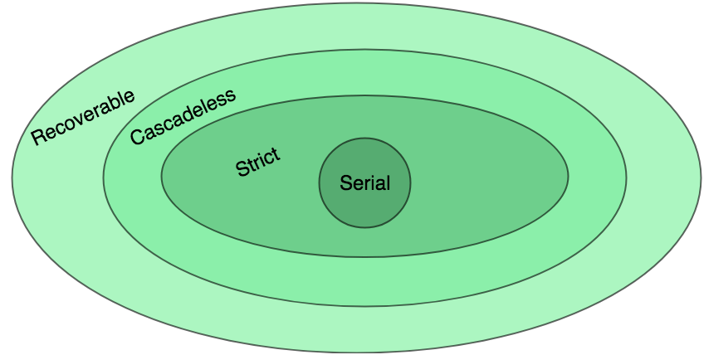

**Serializability 🡪 Conflict serializability   
 🡪 View serializability**

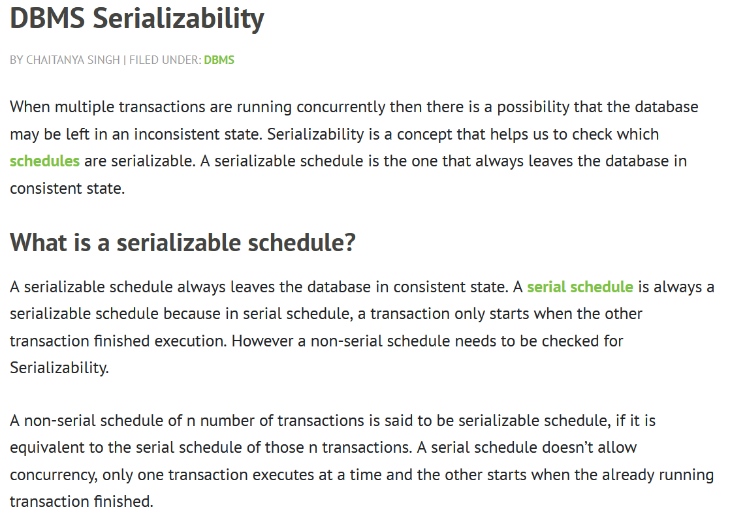

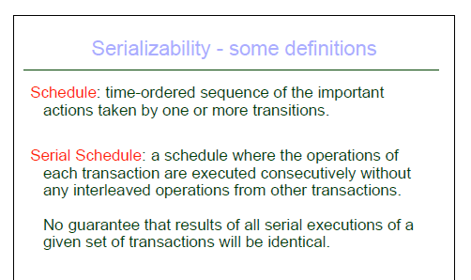

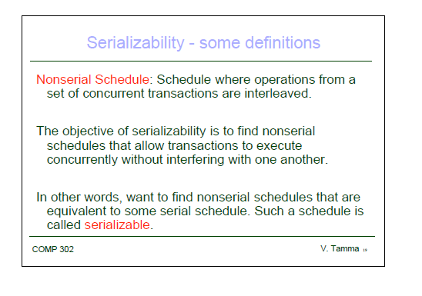

**Conflict Equivalent**

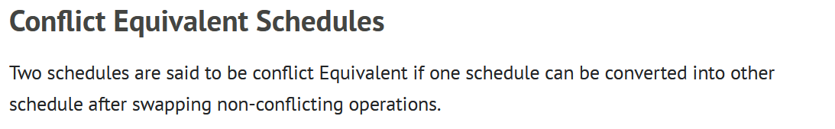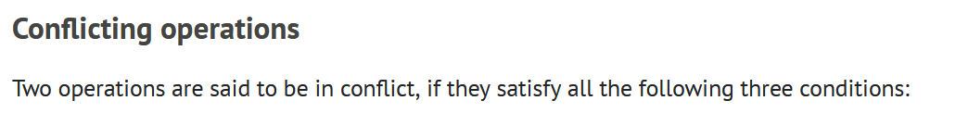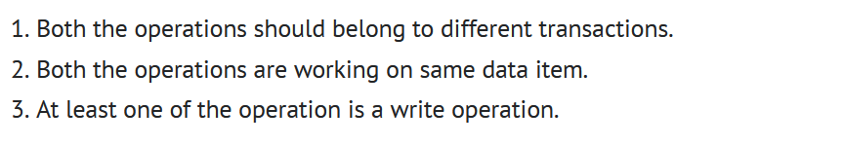

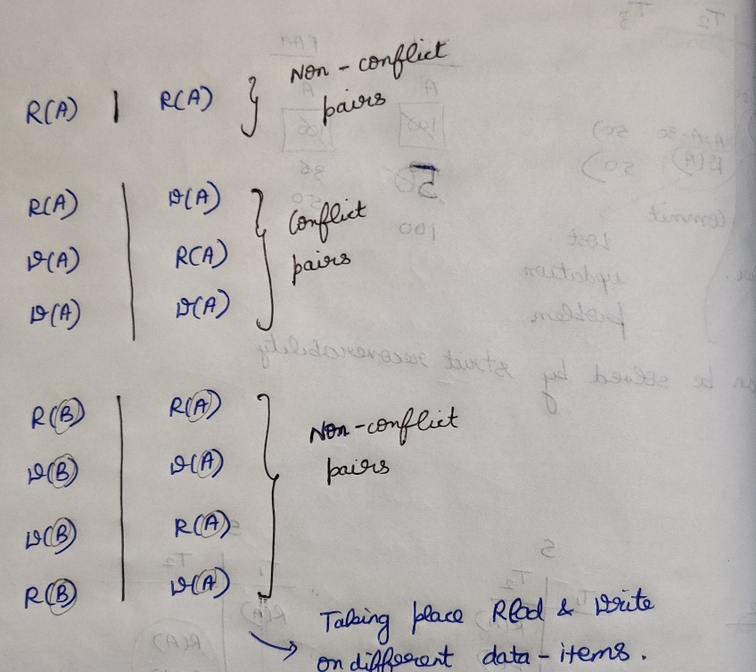

***Adjacent pairs 🡪 Non-conflicting (Change)  
Adjacent pairs 🡪 Conflicting (Don’t Change)***

**If S is conflict equivalent to S’, then S is serializable**

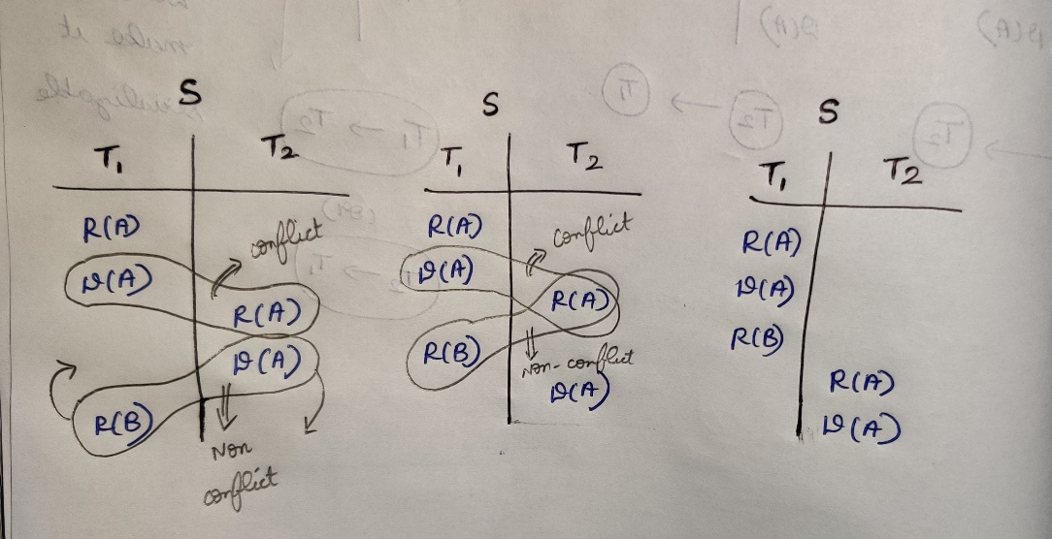

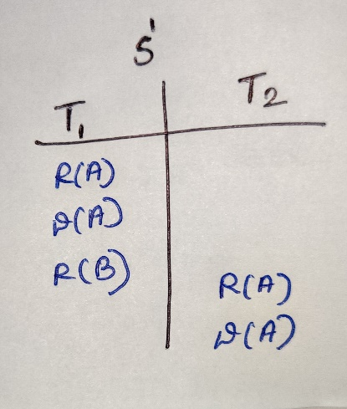

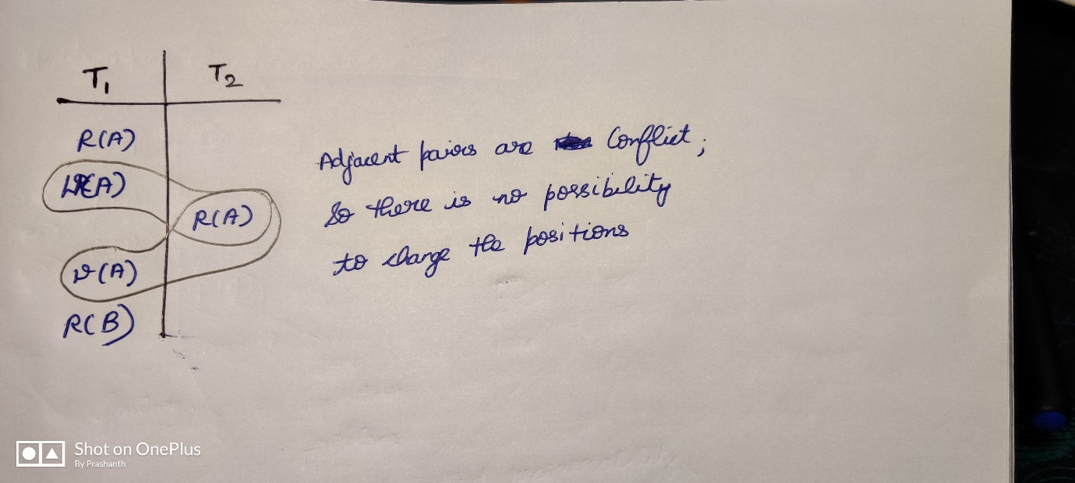

**Conflict serializability** 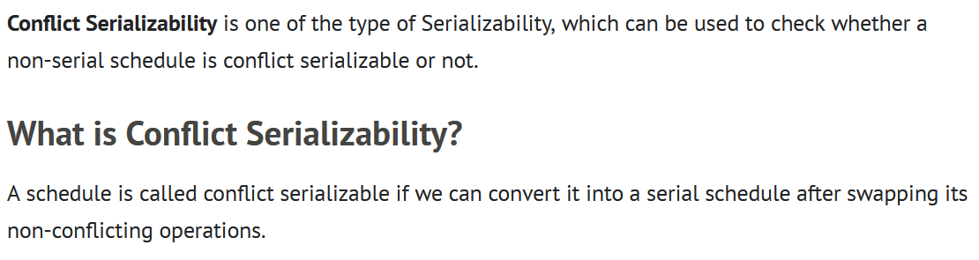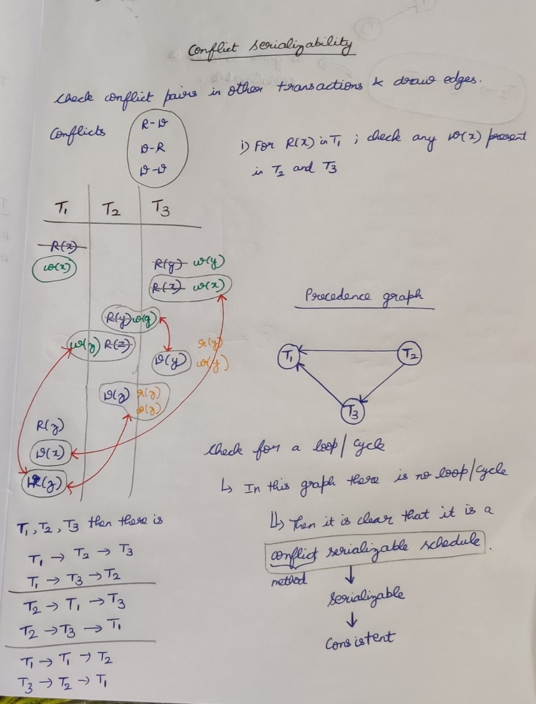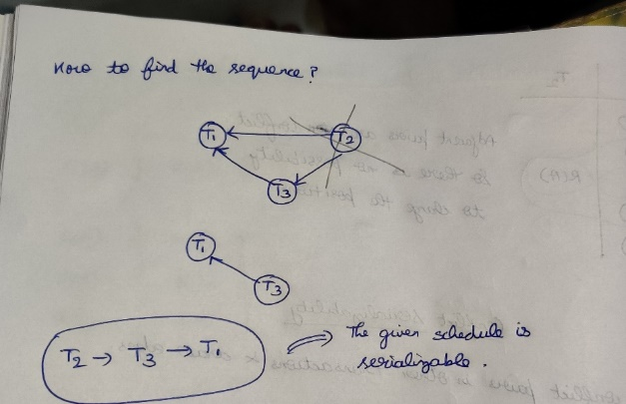

**Question**

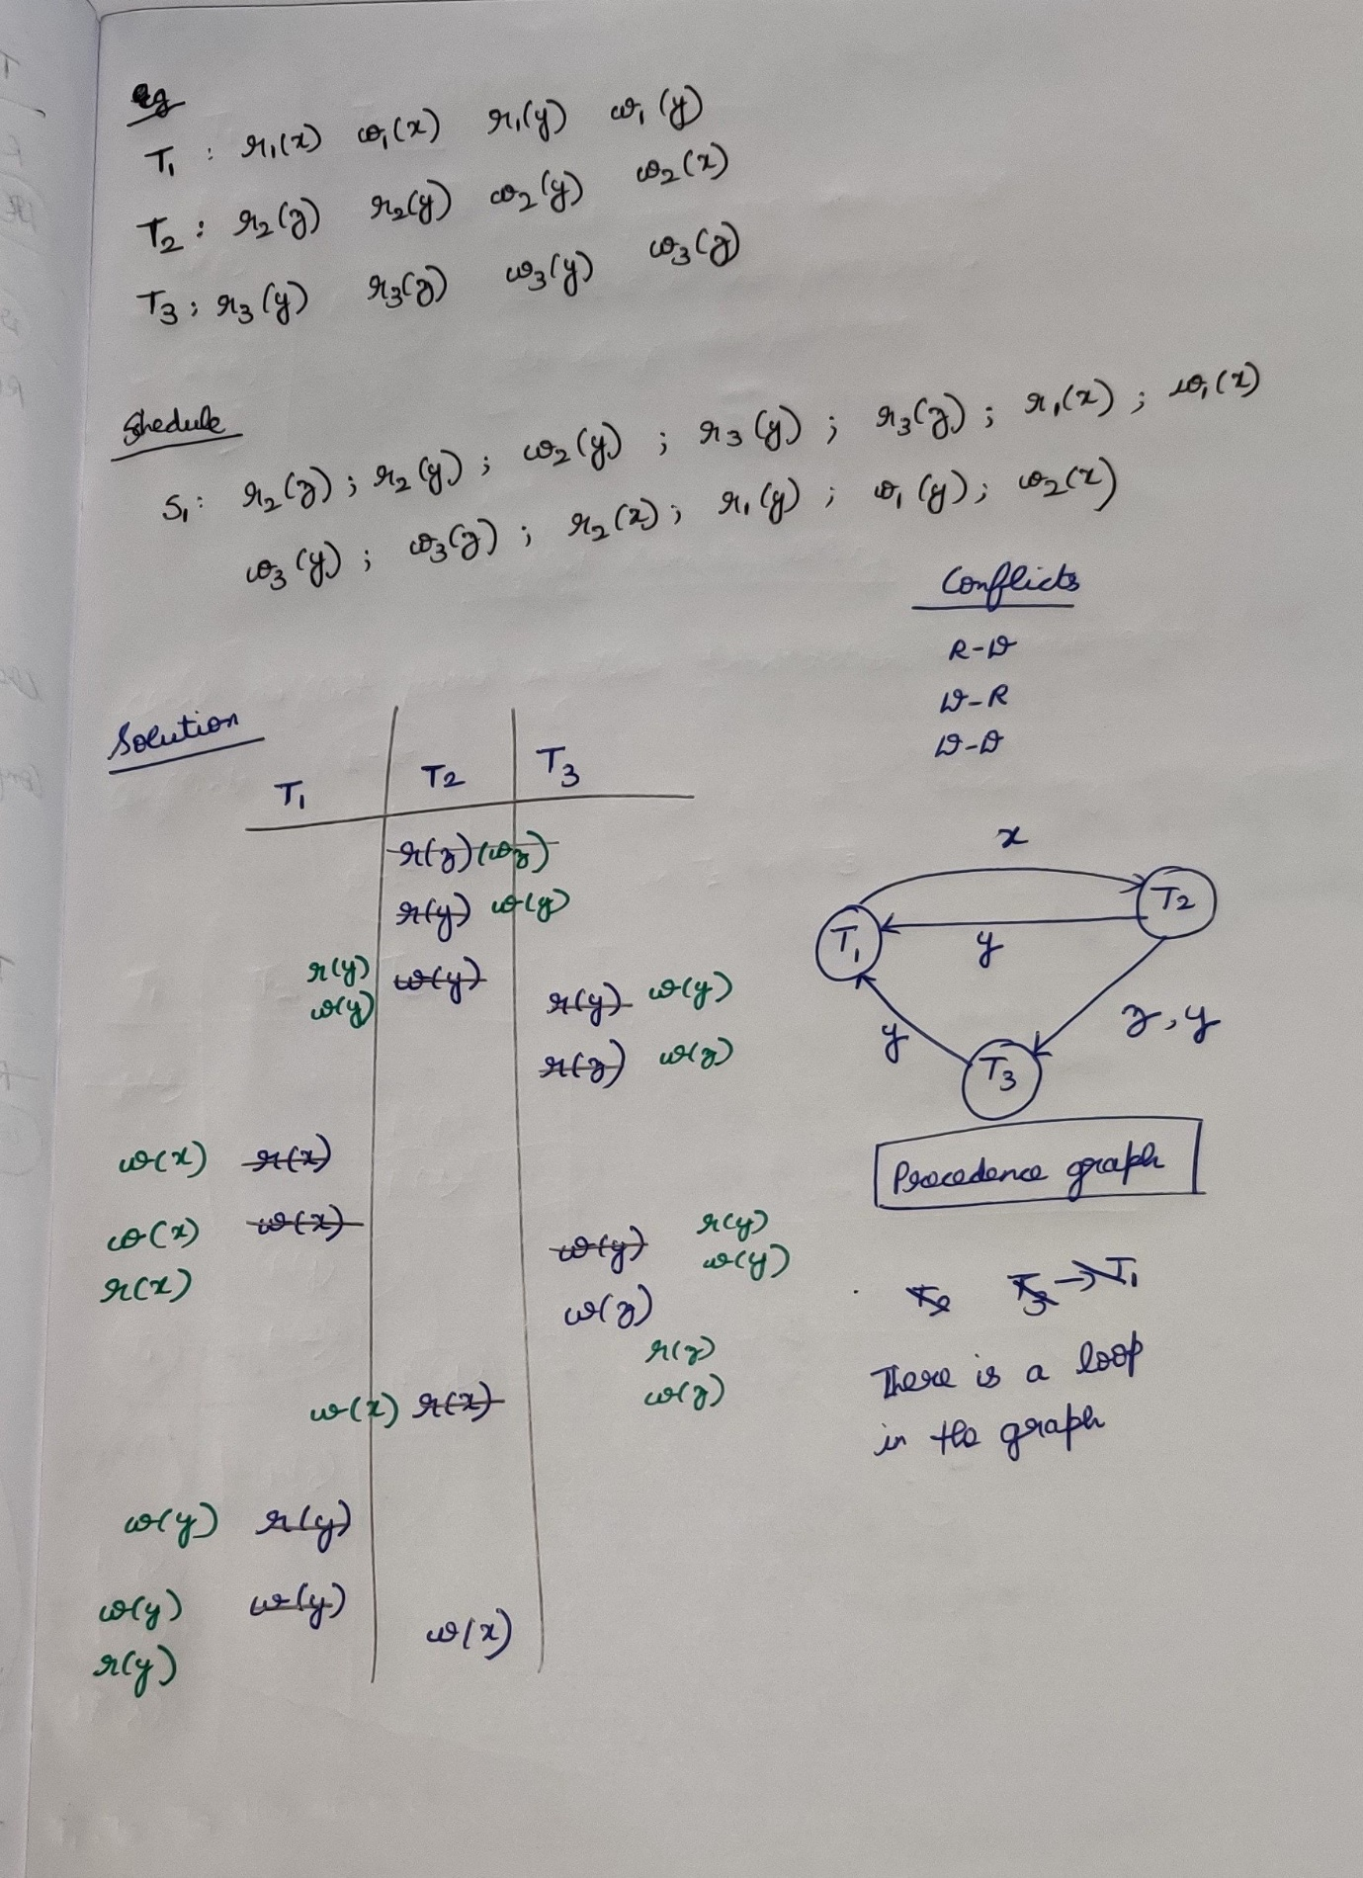

**Question**

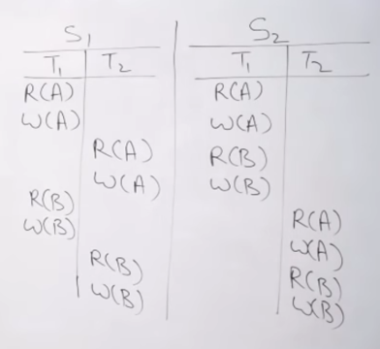

S1 🡪 non-serial  
In S1, I am swapping non-conflicting pairs and obtaining S2 which is serial, then S1 is conflict serializable 🡪 serializable 🡪 conflict.

**Question**An instruction will not conflict with the instruction in the same transaction.

**Question**

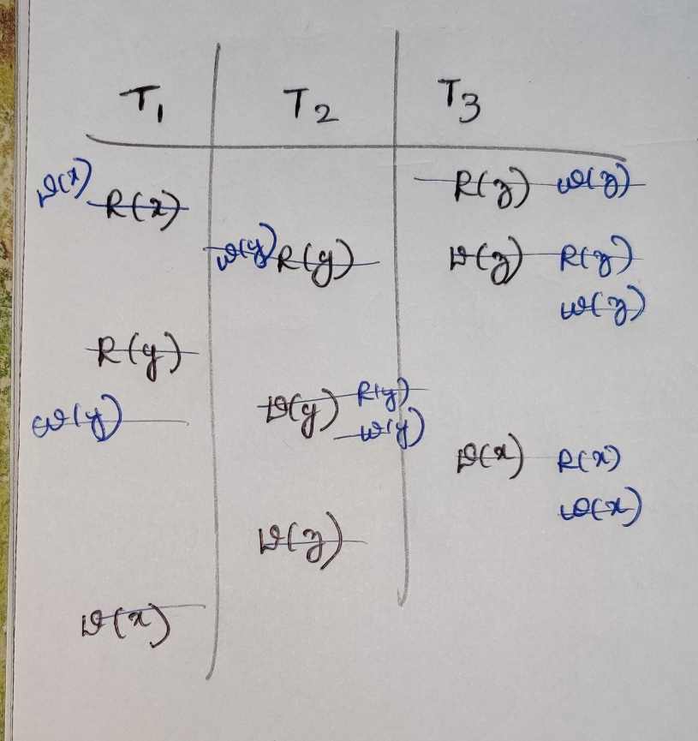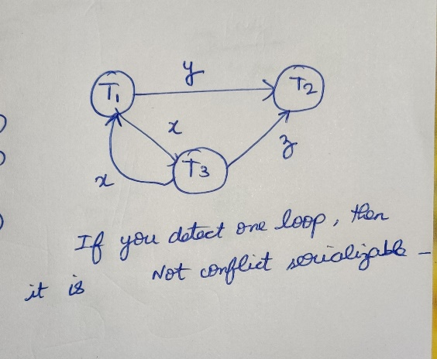

**Question**

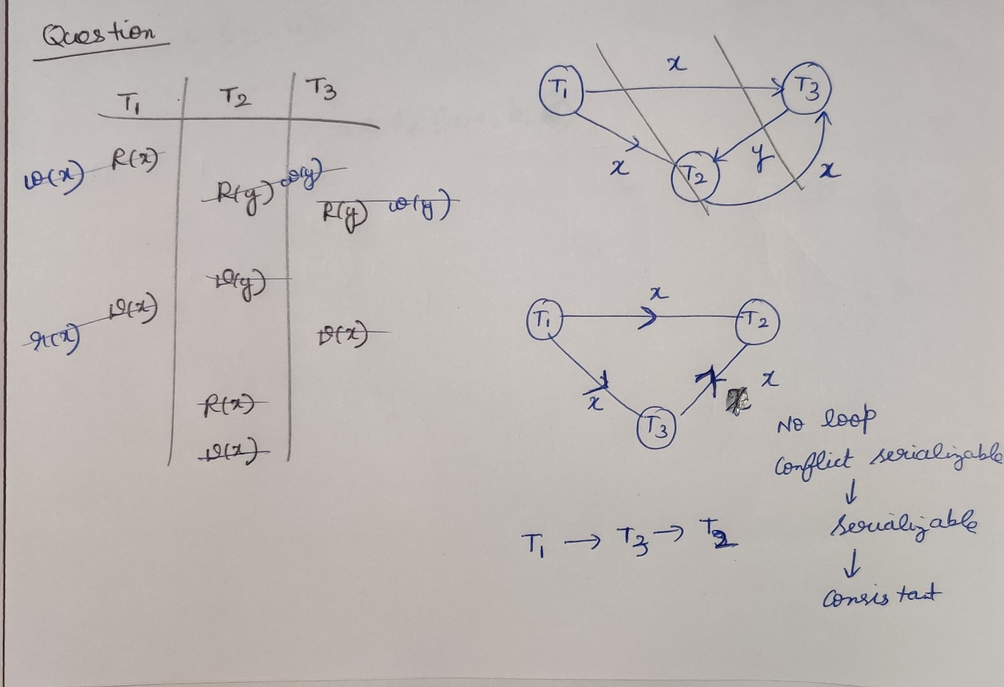

**Question**

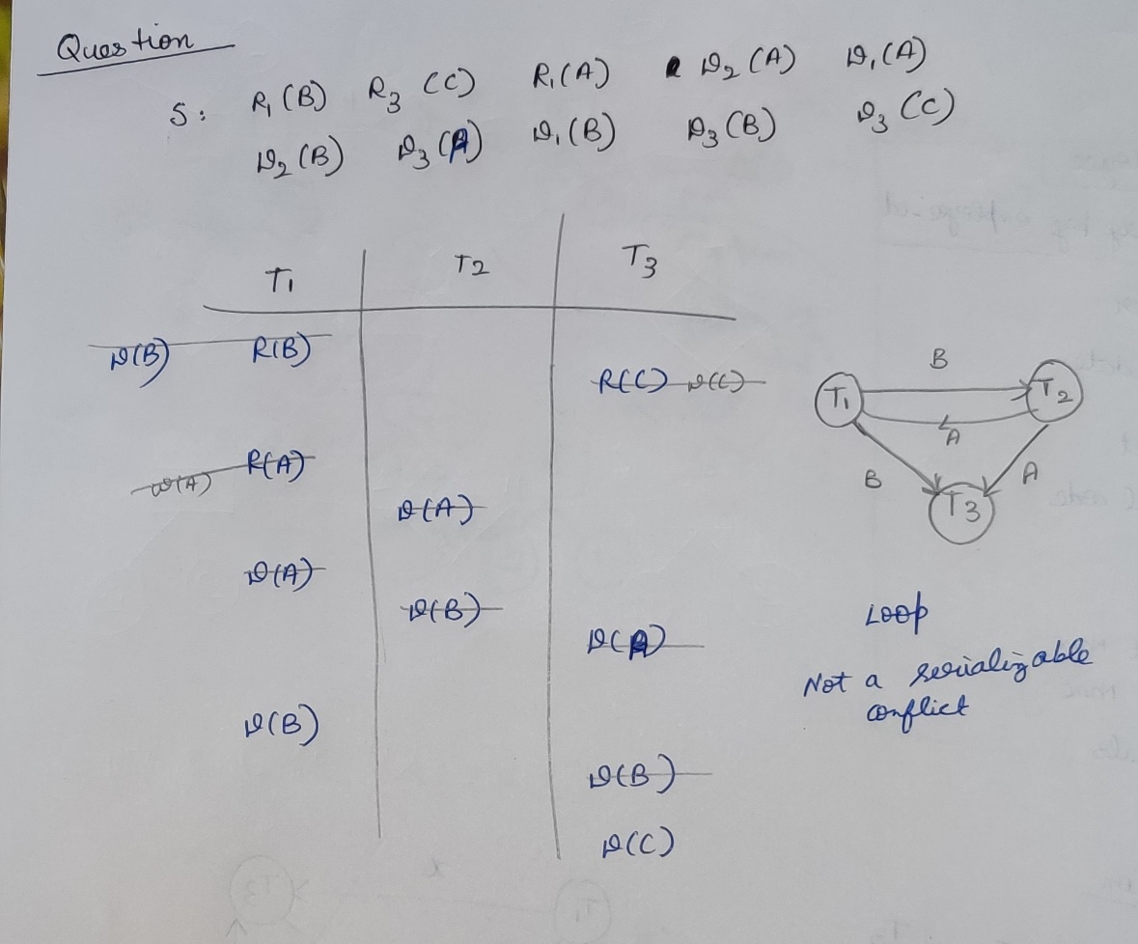

**Question**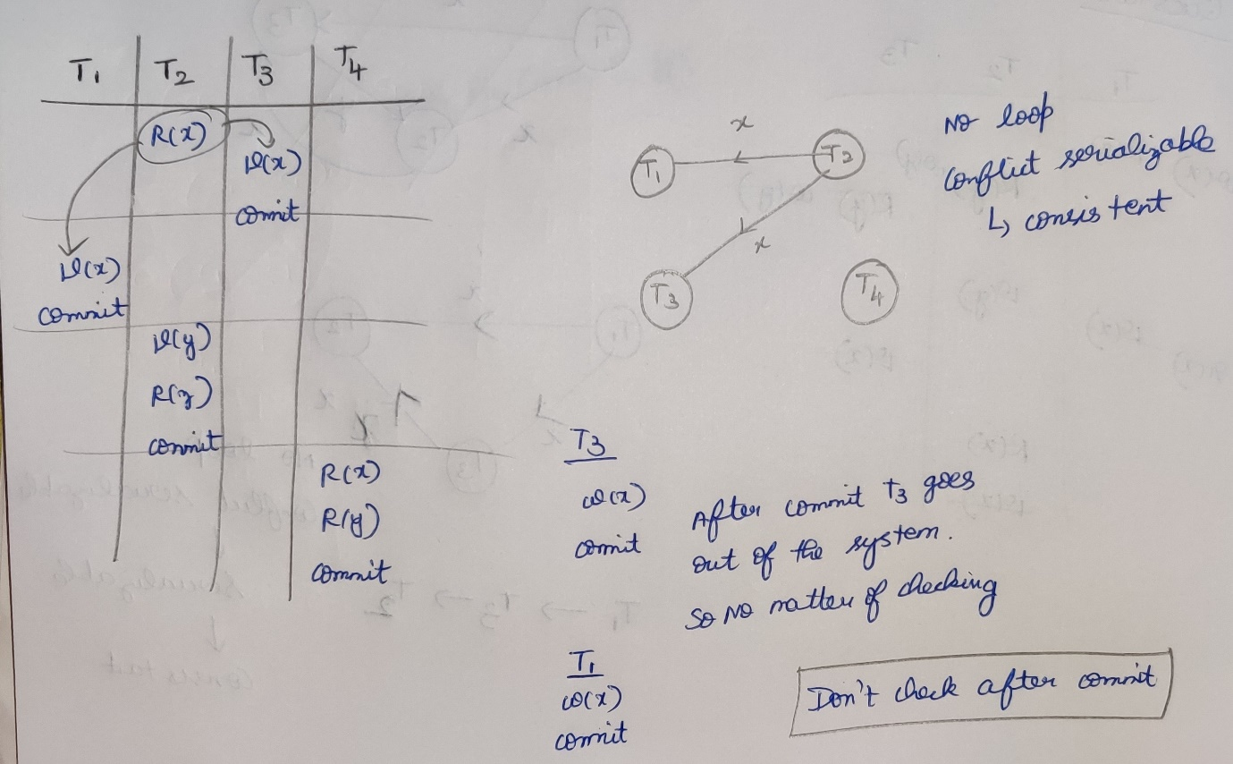

**View serializability**

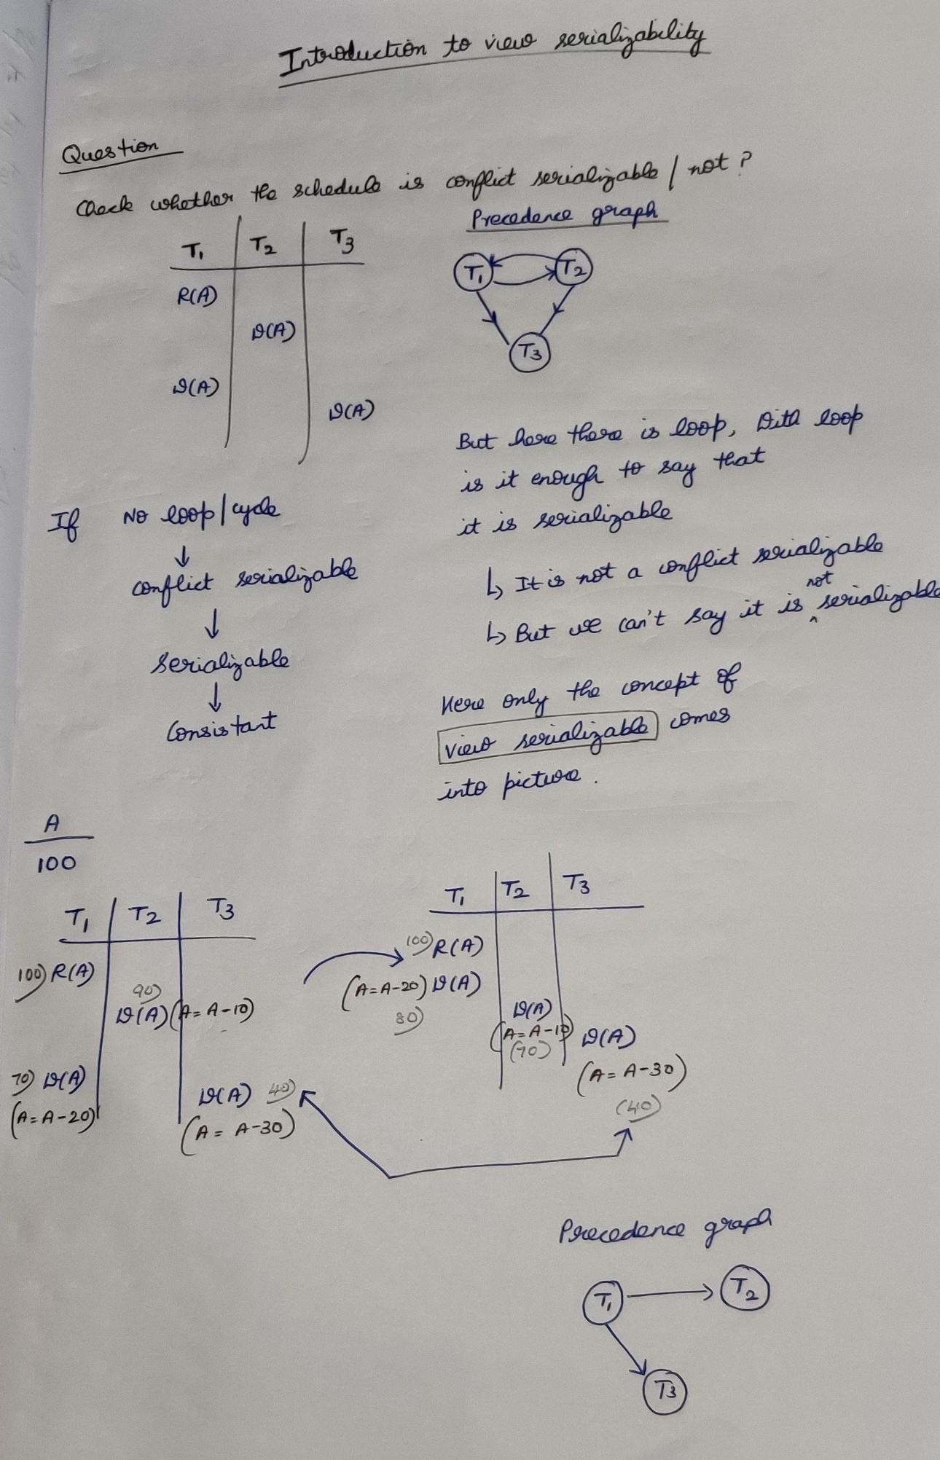



With S , I found the loop, then it is not a conflict serializable.   
This only not enough to say that it is not serializable.  
View Serializable comes into picture.  
In view serializable, I proved that S is serializable (since graph came)

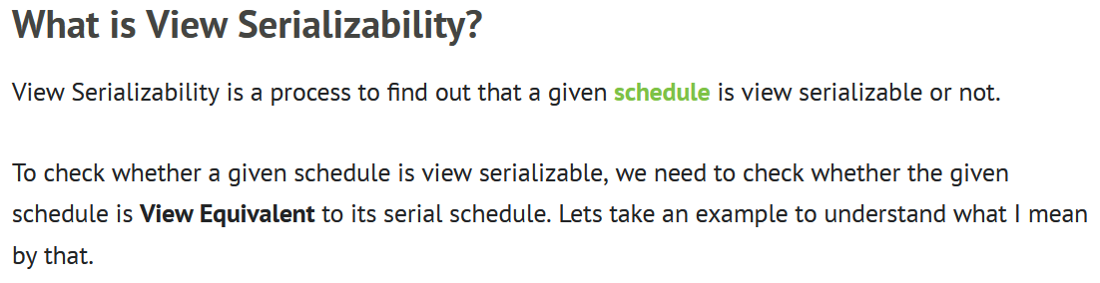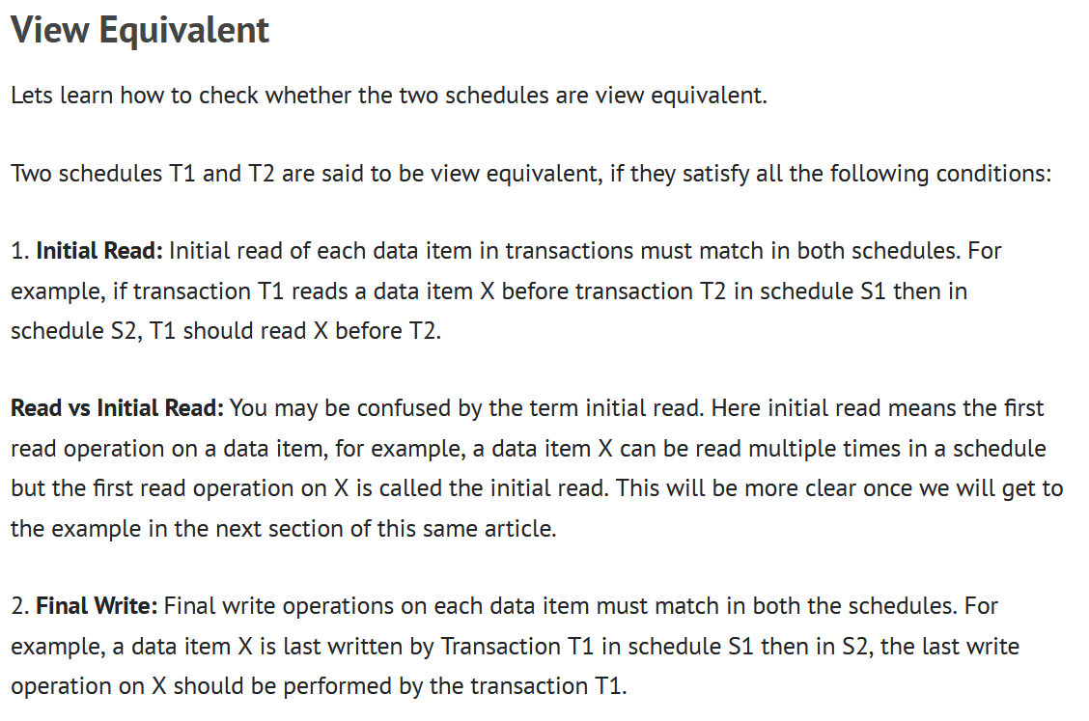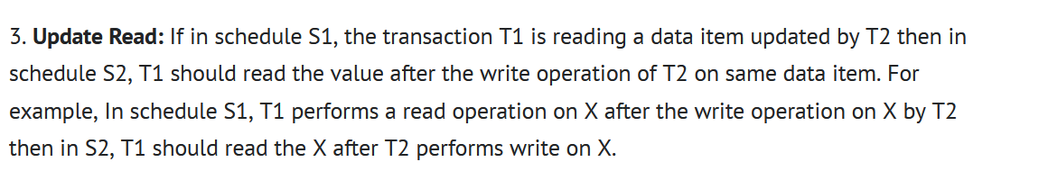



**Initial read 🡪 same   
Final read 🡪 same View Serializable  
write-read conflict 🡪 same**



**Question**

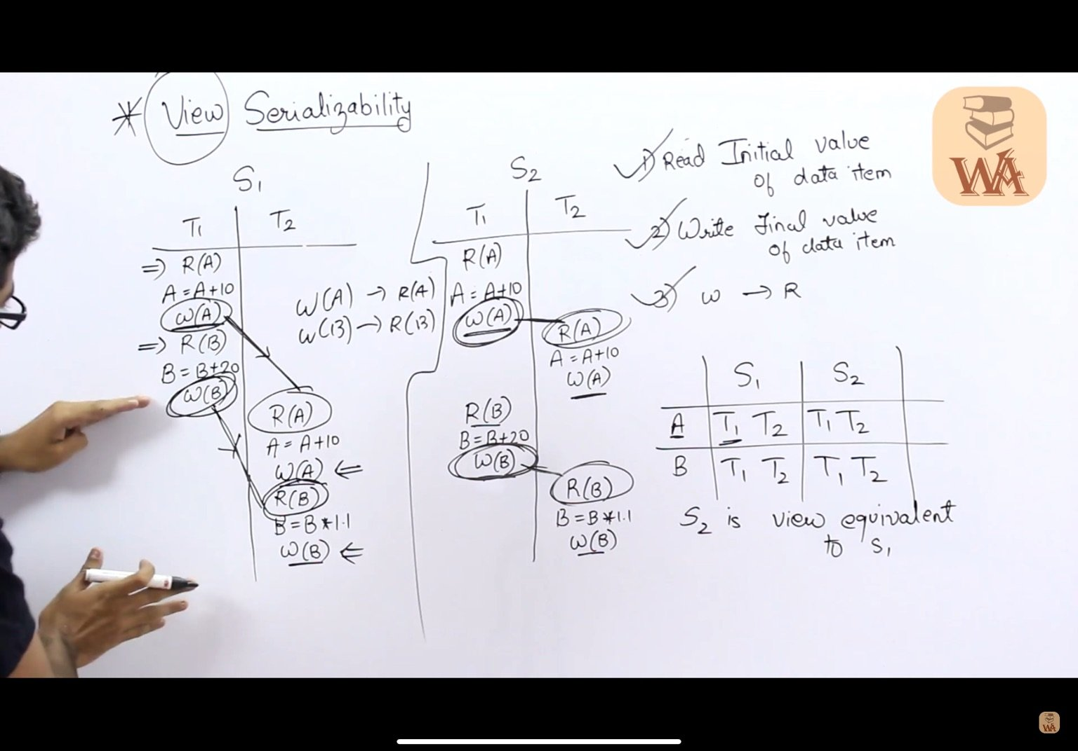

**Question**

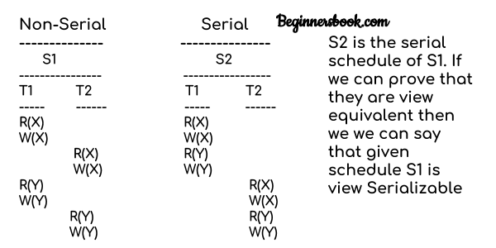



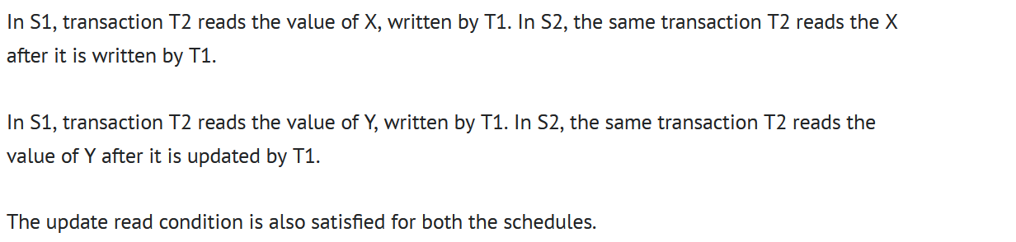

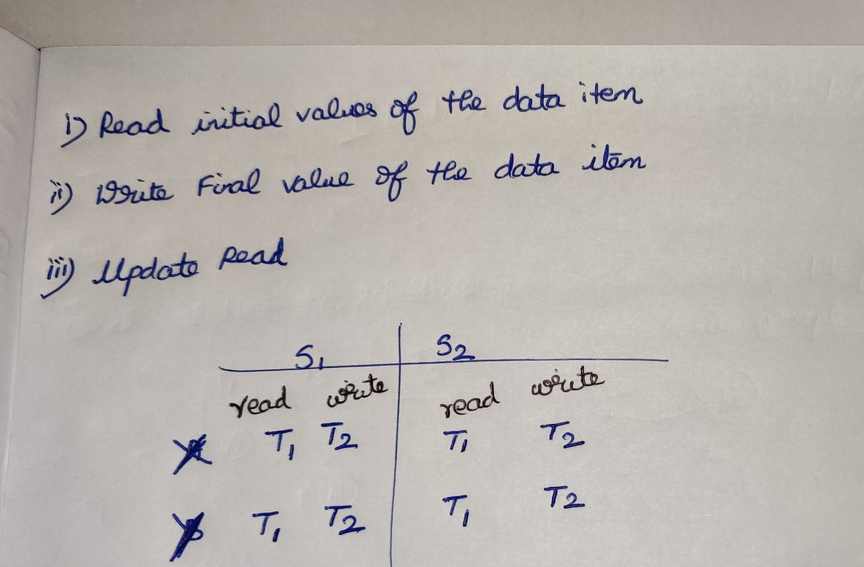

S1 is view equivalent to S2

**Question**

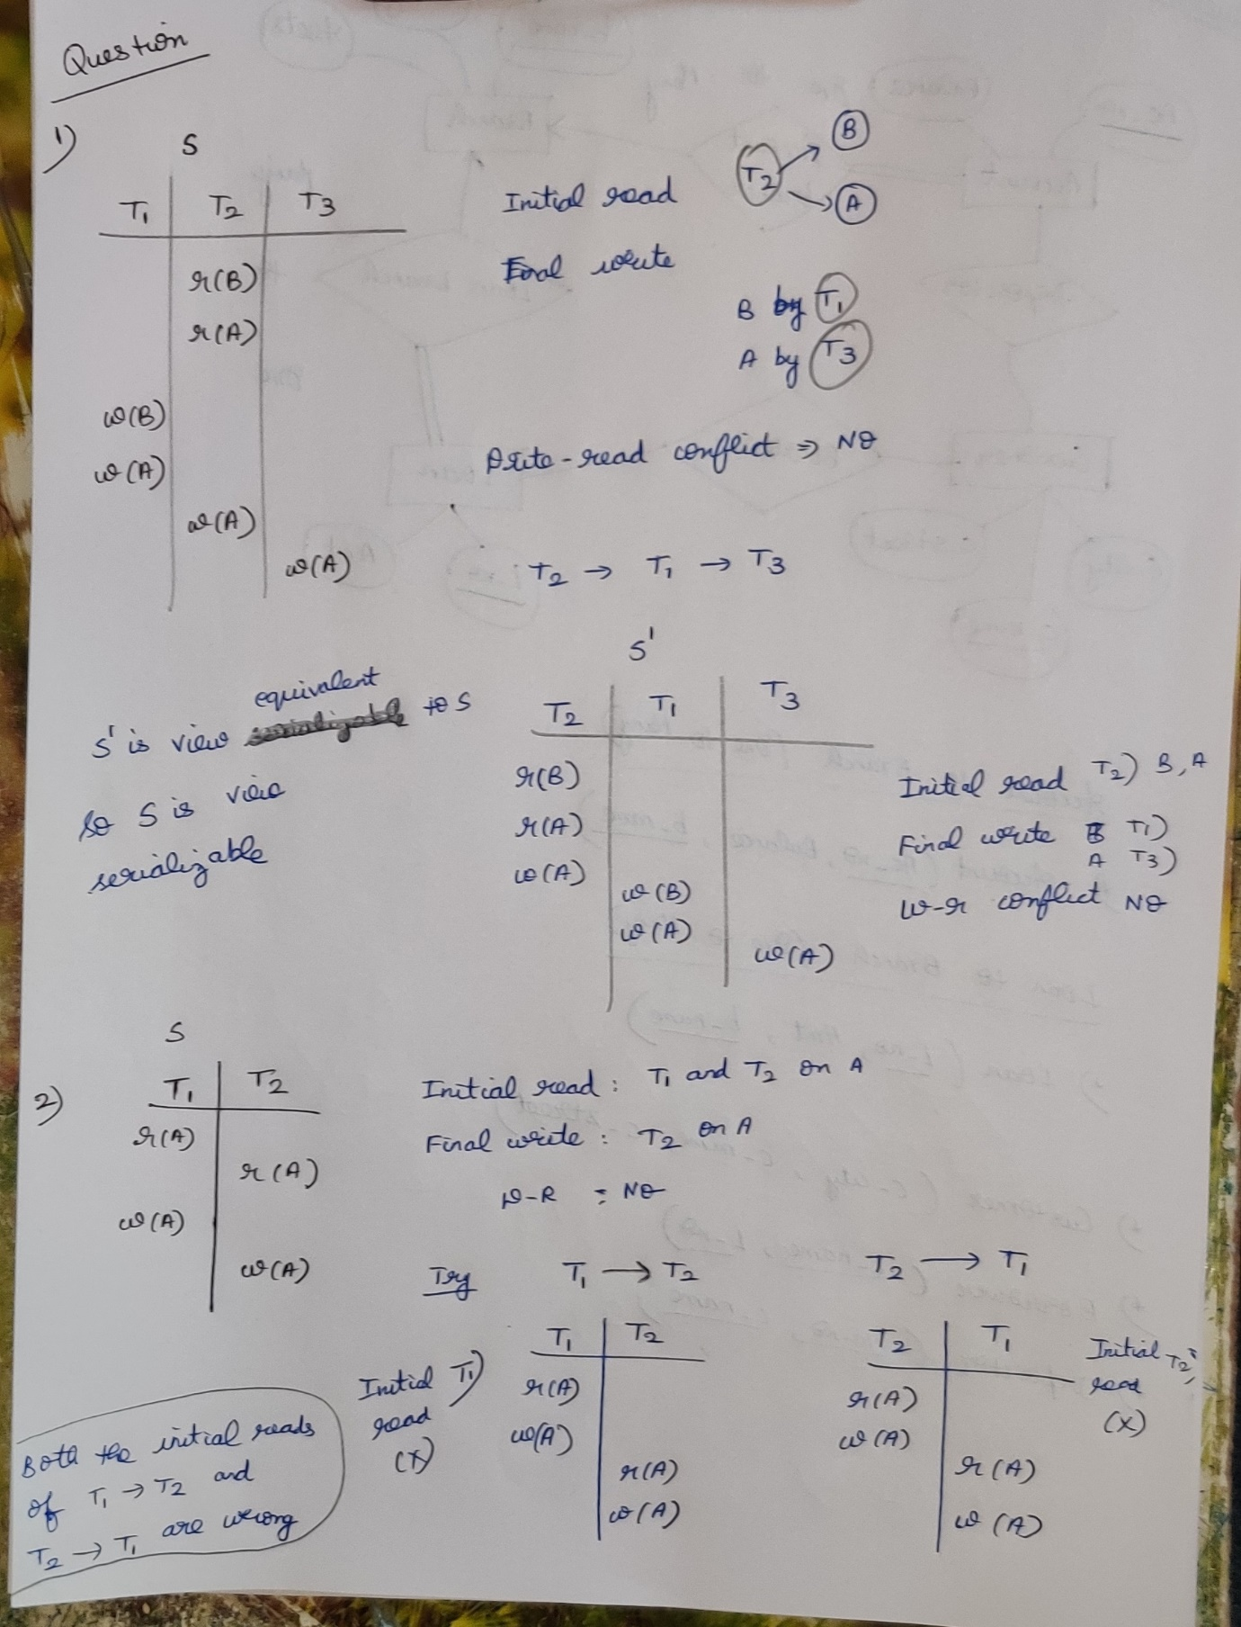

So no view equivalent can be obtained, So the given S is not view serializable.

